

DEPARTMENT OF COMPUTER SCIENCE AND ENGINEERING


U20CS505 - OBJECT ORIENTED ANALYSIS AND DESIGN LABORATORY
Year / Semester: III / V

LAB MANUAL

REGULATION 2020

U20CS505 - OBJECT ORIENTED ANALYSIS AND DESIGN LABORATORY

OBJECTIVES:
- To capture the requirements specification for an intended software system
- To draw the UML diagrams for the given specification
- To map the design properly to code
- To test the software system thoroughly for all scenarios
- To improve the design by applying appropriate design patterns.

Draw standard UML diagrams using an UML modeling tool for a given case study and map design to code and implement a 3 layered architecture. Test the developed code and validate whether the SRS is satisfied.

- Identify a software system that needs to be developed.
- Document the Software Requirements Specification (SRS) for the identified system.
- Identify use cases and develop the Use Case model.
- Identify the conceptual classes and develop a Domain Model and also derive a Class Diagram from that.
- Using the identified scenarios, find the interaction between objects and represent them using UML Sequence and Collaboration Diagrams
- Draw relevant State Chart and Activity Diagrams for the same system.
- Implement the system as per the detailed design
- Test the software system for all the scenarios identified as per the usecase diagram
- Improve the reusability and maintainability of the software system by applying appropriate design patterns.
- Implement the modified system and test it for various scenarios

SUGGESTED DOMAINS FOR MINI-PROJECT:

  - Passport automation system.
  - Book bank
  - Exam registration
  - Stock maintenance system.
  - Online course reservation system
  - Airline/Railway reservation system
  - Software personnel management system
  - Credit card processing
  - e-book management system
  - Recruitment system
  - Foreign trading system
  - Conference management system
  - BPO management system
  - Library management system
  - Student information system

Ex. No.: 1

INTRODUCTION:
CASE TOOLS

CASE tools known as Computer-aided software engineering tools is a kind of component-based development which allows its users to rapidly develop information systems. The main goal of case technology is the automation of the entire information systems development life cycle process using a set of integrated software tools, such as modeling, methodology and automatic code generation. Component based manufacturing has several advantages over custom development. The main advantages are the availability of high quality, defect free products at low cost and at a faster time. The prefabricated components are customized as per the requirements of the customers. The components used are pre-built, ready-tested and add value and differentiation by rapid customization to the targeted customers. However the products we get from case tools are only a skeleton of the final product required and a lot of programming must be done by hand to get a fully finished, good product.

CHARACTERISTICS OF CASE:

Some of the characteristics of case tools that make it better than customized development are;
- It is a graphic oriented tool.
- It supports decomposition of process.

Some typical CASE tools are:
- Unified Modeling Language
- Data modeling tools, and
- Source code generation tools

INTRODUCTION TO UML (UNIFIED MODELING LANGUAGE):

The UML is a language for specifying, constructing, visualizing, and documenting the software system and its components. The UML is a graphical language with sets of rules and semantics. The rules and semantics of a model are expressed in English in a form known as OCL (Object Constraint Language). OCL uses simple logic for specifying the properties

of a system. The UML is not intended to be a visual programming language. However it has a much closer mapping to object-oriented programming languages, so that the best of both can be obtained. The UML is much simpler than other methods preceding it. UML is appropriate for modeling systems, ranging from enterprise information system to distributed web based application and even to real time embedded system. It is a very expensive language addressing all views needed to develop and then to display system even though understand to use. Learning to apply UML effectively starts forming a conceptual mode of languages which requires learning.

Three major language elements:
- UML basic building blocks
- Rules that dictate how this building blocks put together
- Some common mechanism that apply throughout the language The primary goals in the design of UML are:
    - Provides users ready to use, expressive visual modeling language as well so they can develop and exchange meaningful models.
    - Provide extensibility and specialization mechanisms to extend the core concepts.
    - Be independent of particular programming languages and development processes.
    - Provide formal basis for understanding the modeling language.
    - Encourage the growth of the OO tools market.
    - Support higher-level development concepts.
    - Integrate best practices and methodologies.
Every complex system is best approached through a small set of nearly independent views of a model. Every model can be expressed at different levels of fidelity. The best models are connected to reality. The UML defines nine graphical diagrams:

- Class diagram
- Use-case diagram
- Behavior diagram
  - Interaction diagram
    - sequence diagram
    - collaboration diagram
  - state chart diagram
  - activity diagram

- Implementation diagram
4.1component diagram 4.2deployment diagram

UML class diagram:

The UML class diagram is also known as object modeling. It is a static analysis diagram. These diagrams show the static structure of the model. A class diagram is a connection of static model elements, such as classes and their relationships, connected as a graph to each other and to their contents.

Use-case diagram:

The functionality of a system can be described in a number of different use-cases, each of which represents a specific flow of events in a system. It is a graph of actors, a set of use-cases enclosed in a boundary, communication, associations between the actors and the use-cases, and generalization among the use-cases.

Behavior diagram:

It is a dynamic model unlike all the others mentioned before. The objects of an object oriented system are not static and are not easily understood by static diagrams. The behavior of the class’s instance (an object) is represented in this diagram. Every use-case of the system has an associated behavior diagram that indicates the behavior of the object. In conjunction with the use-case diagram we may provide a script or interaction diagram to show a time line of events. It consists of sequence and collaboration diagrams.

Interaction diagram

It is the combination of sequence and collaboration diagram. It is used to depict the flow of events in the system over a timeline. The interaction diagram is a dynamic model which shows how the system behaves during dynamic execution.

State chart diagram:
It consists of state, events and activities. State diagrams are a familiar technique to describe the behavior of a system. They describe all of the

possible states that a particular object can get into and how the object's state changes as a result of events that reach the object. In most OO techniques, state diagrams are drawn for a single class to show the lifetime behavior of a single object.

Activity diagram:

It shows organization and their dependence among the set of components. These diagrams are particularly useful in connection with workflow and in describing behavior that has a lot of parallel processing. An activity is a state of doing something: either a real-world process, or the execution of a software routine.

Implementation diagram:

It shows the implementation phase of the systems development, such as the source code structure and the run-time implementation structure. These are relatively simple high level diagrams compared to the others seen so far. They are of two sub-diagrams, the component diagram and the deployment diagram.

Component diagram:

These are organizational parts of a UML model. These are boxes to which a model can be decomposed. They show the structure of the code itself. They model the physical components such as source code, user interface in a design. It is similar to the concept of packages.

Deployment diagram:

The deployment diagram shows the structure of the runtime system. It shows the configuration of runtime processing elements and the software components that live in them. They are usually used in conjunction with deployment diagrams to show how physical modules of code are distributed on the system.

NOTATION ELEMENTS:

These are explanatory parts of UML model. They are boxes which may apply to describe and remark about any element in the model. They

provide the information for understanding the necessary details of the diagrams.

Relations in the UML:

are:
These are four kinds of relationships used in an UML diagram, they

- Dependency
- Association
- Generalization
- Realization

Dependency:

It is a semantic relationship between two things in which a change one thing affects the semantics of other things. Graphically a dependency is represented by a non-continuous line.

Association:

It is a structural relationship that describes asset of links. A link is being connected among objects. Graphically association is represented as a solid line possibly including label.

Generalization:

It is a specialized relationship in which the specialized elements are substitutable for object of the generalized element. Graphically it is a solid line with hollow arrow head parent.

Realization:

It is a semantic relation between classifiers. Graphically it is represented as a cross between generalization and dependency relationship.

Where UML can be used:

UML is not limited to modeling software. In fact it is expressive to model non-software such as to show in structure and behavior of health case system and to design the hardware of the system.

Conceptual model be UML:

UML you need to form the conceptual model of UML. This requires three major elements:
  - UML basic building blocks.
  - Rules that dictate how this building blocks are put together.
  - Some common mechanism that apply throughout the language.

Once you have grasped these ideas, you may be able to read. UML create some basic ones. As you gain more experience in applying conceptual model using more advanced features of this language.

Building blocks of the UML:

The vocabulary of UML encompasses these kinds of building blocks.

Use CASE definition:

Description:
A use case is a set of scenarios tied together by a common user goal. A use case is a behavioral diagram that shows a set of use case actions and their relationships.

Purpose:
The purpose of use case is login and exchange messages between sender and receiver (Email client).

Main flow:

First, the sender gives his id and enters his login. Now, he enters the message to the receiver id.

Alternate flow:

If the username and id by the sender or receiver is not valid, the administrator will not allow entering and “Invalid password” message is displayed.

Pre-condition:

A person has to register himself to obtain a login ID.

Post-condition:

The user is not allowed to enter if the password or user name is not
valid.

Class diagram:

Description:

- A class diagram describes the type of objects in system and various kinds of relationships that exists among them.
- Class diagrams and collaboration diagrams are alternate representations of object models.

During analysis, we use class diagram to show roles and responsibilities of entities that provide email client system behaviors design. We use to capture the structure of classes that form the email client system architecture.

A class diagram is represented as:

<<Class name>>
<<Attribute 1>>
<<Attribute n>>
<<Operation ()>>

Relationship used:

A change in one element affects the other

Generalization:

It is a kind of relationship

State chart:
Description:

- The state chart diagram made the dynamic behavior of individual classes.
- State chart shows the sequences of states that an object goes through events and state transitions.
- A state chart contains one state ‘start’ and multiple ‘end’ states.

The important objectives are:

Decision:

It represents a specific location state chart diagram where the work flow may branch based upon guard conditions.

Synchronization:

It gives a simultaneous workflow in a state chart diagram. They visually define forks and joints representing parallel workflow.

Forks and joins:

  - A fork construct is used to model a single flow of control.
  - Every work must be followed by a corresponding join.
  - Joints have two or more flow that unit into a single flow.

State:

A state is a condition or situation during a life of an object in which it satisfies condition or waits for some events.
Transition:

It is a relationship between two activities and between states and activities.

Start state:

A start state shows the beginning of a workflow or beginning of a state machine on a state chart diagram.

End state:
It is a final or terminal state.

Activity diagram Description:
Activity diagram provides a way to model the workflow of a development process. We can also model this code specific information such as class operation using activity diagram. Activity diagrams can model different types of diagrams. There are various tools involved in the activity diagram.

Activity:

An activity represents the performance of a task on duty. It may also represent the execution of a statement in a procedure.

Decision:

A decision represents a condition on situation during the life of an object, which it satisfies some condition or waits for an event.

Start state:

It represents the condition explicitly the beginning of a workflow on an activity.

Object flow:

An object on an activity diagram represents the relationship between activity and object that creates or uses it.

Synchronization:

It enables us to see a simultaneous workflow in an activity.

End state:
An end state represents a final or terminal state on an activity diagram or state chart diagram.

Sequence diagram:

Description:

A sequence diagram is a graphical view of scenario that shows object interaction in a time based sequence what happens first what happens next. Sequence diagrams are closely related to collaboration diagram.
The main difference between sequence and collaboration diagram is that sequence diagram show time based interaction while collaboration diagram shows objects associated with each other.

The sequence diagram for the e-mail client system consists of the following objectives:

Object:

An object has state, behavior and identity. An object is not based is referred to as an instance.
The various objects in e-mail client system are:
    - User
    - Website
    - Login
    - Groups

Message icon:

A message icon represents the communication between objects indicating that an action will follow. The message icon is the horizontal solid arrow connecting lifelines together.

Collaboration diagram:

Description:

Collaboration diagram and sequence diagrams are alternate representations of an interaction. A collaboration diagram is an interaction diagram that shows the order of messages that implement an operation or a transaction. Collaboration diagram is an interaction diagram that shows the order of messages that implement an operation or a transaction.
Collaboration diagram shows object s, their links and their messages. They can also contain simple class instances and class utility instances.

During, analysis indicates the semantics of the primary and secondary interactions. Design, shows the semantics of mechanisms in the logical design of system.
Toggling between the sequence and collaboration diagrams

CONCLUSION:
Thus the study for case tools was done.

Ex no:2

PASSPORT AUTOMATION SYSTEM

AIM:
To create an automated system to perform the Passport Process.

PROBLEM STATEMENT:

Passport Automation System is used in the effective dispatch of passport to all of the applicants. This system adopts a comprehensive approach to minimize the manual work and schedule resources, time in a cogent manner. The core of the system is to get the online registration form (with details such as name, address etc.,) filled by the applicant whose testament is verified for its genuineness by the Passport Automation System with respect to the already existing information in the database.

( II )SOFTWARE REQUIREMENT SPECIFICATION: 2.1SOFTWARE INTERFACE
  - Front End Client - The applicant and Administrator online interface is built using
JSP and HTML. The Administrators's local interface is built using Java.
  - Web Server - Glassfish application server(Oracle Corporation).
  - Back End - Oracle database.

2.2HARDWARE INTERFACE

The server is directly connected to the client systems. The client systems have access to the database in the server.

( III ) USECASE DIAGRAM :
registration
enter applicant id
check status
administrator
applicant
process applicant
dispatch passport

Fig.3. USECASE DIAGRAM FOR PASSPORT AUTOMATION SYSTEM

- ACTIVITY DIAGRAM:
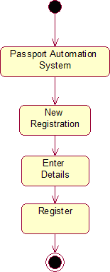

Fig.4.1. ACTIVITY DIAGRAM FOR REGISTER

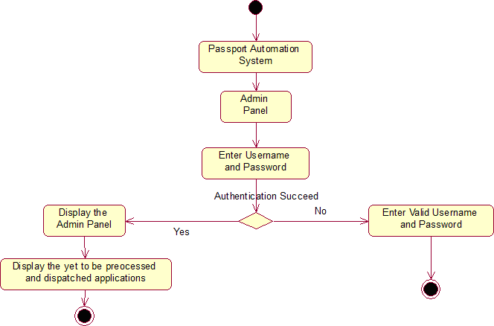
Fig.4.2. ACTIVITY DIAGRAM FOR ADMINISTRATION
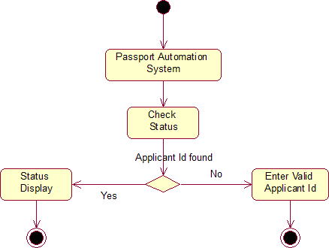

Fig.4.3. ACTIVITY DIAGRAM FOR CHECKING STATUS

- CLASS DIAGRAM:

The class diagram, also referred to as object modeling is the main static analysis diagram. The main task of object modeling is to graphically show what each object will do in the problem domain. The problem domain describes the structure and the relationships among objects.
The Passport Automation system class diagram consists of four classesPassport Automation System
  - New registration
  - Gender
  - Application Status
  - Admin authentication
  - Admin Panel

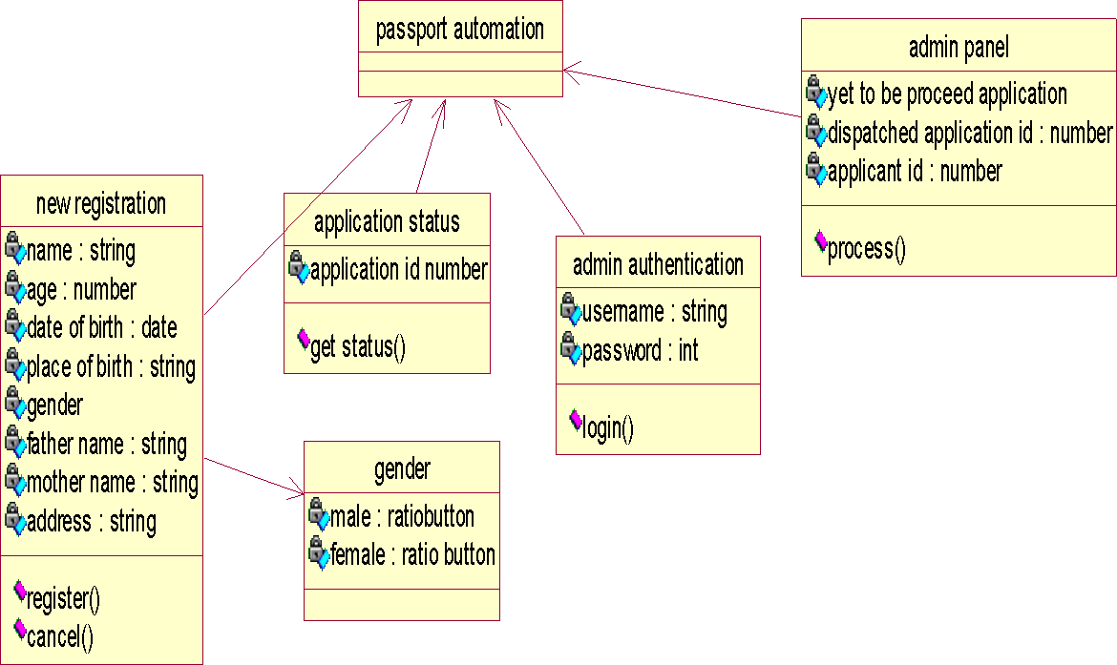

Fig.5. CLASS DIAGRAM FOR PASSPORT AUTOMATION SYSTEM

- INTERACTION DIAGRAM:

A sequence diagram represents the sequence and interactions of a given USE-CASE or scenario. Sequence diagrams can capture most of the information about the system. Most object to object interactions and operations are considered events and events include signals, inputs, decisions, interrupts, transitions and actions to or from users or external devices.
An event also is considered to be any action by an object that sends information. The event line represents a message sent from one object to another, in which the “form” object is requesting an operation be performed by the “to” object. The “to” object performs the operation using a method that the class contains.
It is also represented by the order in which things occur and how the objects in the system send message to one another.
The sequence diagram for each USE-CASE that exists when a user administrator, check status and new registration about passport automation system are given.

1: 1.username\password
2: authetication suceed

3: details of application yet to be released
4: details of application dispatched
5: enter applicant id to process
6: give details
7: dispatch eligible passports
database
application
admin panel
system
administrator

Fig.6.1.SEQUENCE DIAGRAM FOR ADMINISTRATOR
admin
panel

1: 1.username\password
2: authetication suceed

administrator
system
admin panel
database
application
administ
rator
system

5: enter applicant id to process 4: details of application dispatched

7: dispatch eligible passports

6: give details

3: details of application yet to be released
databas
e
applicati
on

Fig.6.2.COLLABORATION DIAGRAM FOR ADMINISTRATOR

The diagrams show the process done by the administrator to the Passport Automation system. The applicant has to enter his details. The

details entered are verified by the administrator and the applicant is approved if the details match then the passport is dispatch, otherwise an appropriate error message is displayed.
applicant
system
database

1: enter applicant id
2: fetch details for the applicant
3: display the status
database
applicant
system

Fig.6.3.SEQUENCE DIAGRAM FOR CHECKING STATUS

1: enter applicant id 3: display the status

2: fetch details for the applicant
applicant
databas
e
system

Fig.6.4.COLLABORATION DIAGRAM FOR CHECKING STATUS

The diagrams show the applicant enters his id and the system fetch the details from the database and display the status.
applicant
system
database

1: request for registeration
2: registeration form
3: fill in details

4: submit

5: give applicatino id
6: store full deatils
system
database
applicant

Fig.6.5.SEQUENCE DIAGRAM FOR NEW REGISTRATION

1: request for registeration 3: fill in details
4: submit
system
applicant
5: give applicatino id 2: registeration form

6: store full deatils

databas
e

Fig.6.6.COLLABORATION DIAGRAM FOR NEW REGISTRATION

The diagrams show the applicant request the system for registration and the system provide the register form and applicant fill the form and submit and the system give the applicant id. The database stores the full details.

PARTIAL LAYERD LOGICAL ARCHITECTURE DIAGRAM

UI
Swing | Passport auto system | Text | PassAuto Console

Domain
Registration  Register | Cancel  Authentication |  | Admin panel  Process  Login | Balance
Technical Services
SOAP
Log4J
Persistence
DBFacade

- DEPLOYMENT DIAGRAM AND COMPONENT DIAGRAM
Deployment diagrams are used to visualize the topology of the physical components of a system where the software components are deployed.
<<database>>
:MySQL
<<client workstation>>
:GenericPC
SQL
HTT
<<server>> :T omcat6

DEPLOYMENT DIAGRAM COMPONENT DIAGRAM
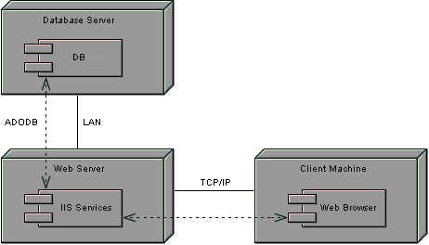
Component diagrams are used to visualize the organization and relationship among components in system

RESULT:
Thus the mini project for passport automation system has been successfully executed and codes are generated.

Ex no:3

BOOK BANK SYSTEM

AIM:
To create a system to perform book bank operation

PROBLEM STATEMENT:

A Book Bank lends books and magazines to member, who is registered in the system. Also it handles the purchase of new titles for the Book Bank. Popular titles are brought into multiple copies. Old books and magazines are removed when they are out or date or poor in condition. A member can reserve a book or magazine that is not currently available in the book bank, so that when it is returned or purchased by the book bank, that person is notified. The book bank can easily create, replace and delete information about the tiles, members, loans and reservations from the system.

SOFTWARE REQUIREMENTS SPECIFICATION: 2.1SOFTWARE INTERFACE
  - Front End Client - The Student and Librarian online interface is built using JSP and HTML. The Librarians local interface is built using Java.
  - Web Server - Glassfish application server (Oracle Corporation).
  - Back End - Oracle database

2.2HARDWARE INTERFACE

The server is directly connected to the client systems. The client systems have access to the database in the server.

USE-CASE DIAGRAM:

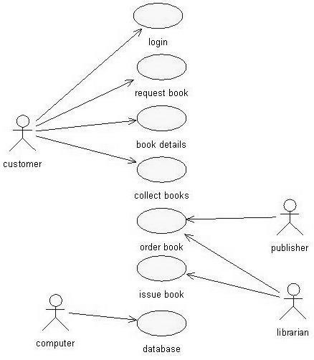

Fig 3. USE-CASE DIAGRAM FOR BOOK BANK SYSTEM

ACTIVITY DIAGRAM:
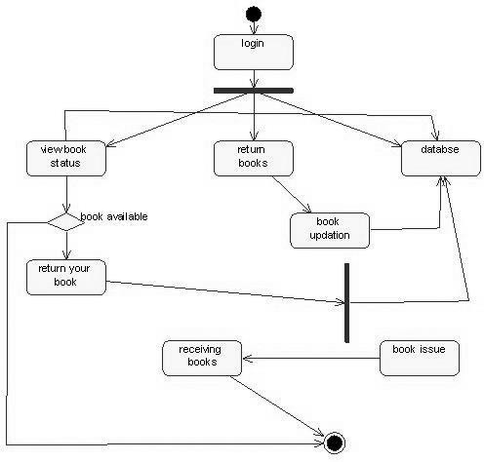

Fig.4. ACTIVITY DIAGRAM

CLASS DIAGRAM:

The class diagram, also referred to as object modeling is the main static analysis diagram. The main task of object modeling is to graphically show what each object will do in the problem domain. The problem domain describes the structure and the relationships among objects.

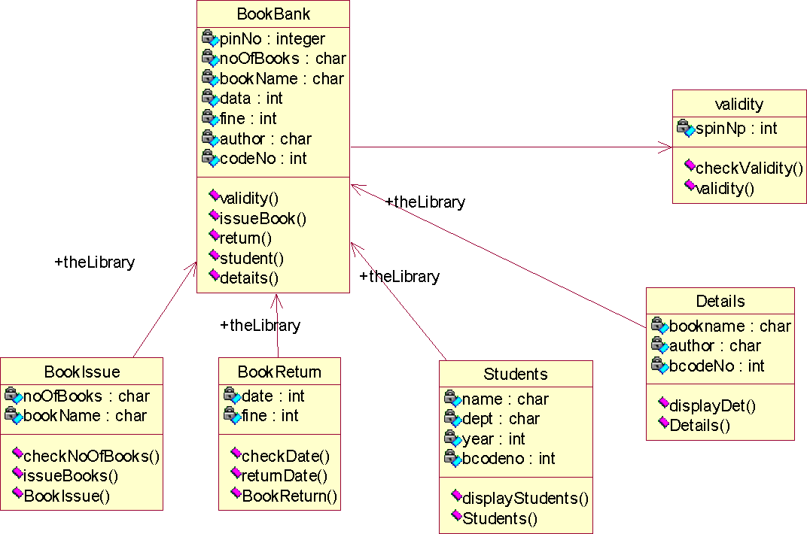

Fig.5. CLASS DIAGRAM FOR BOOK BANK SYSTEM

- SEQUENCE DIAGRAM:

A sequence diagram represents the sequence and interactions of a given USE-CASE or scenario. Sequence diagrams can capture most of the information about the system. Most object to object interactions and operations are considered events and events include signals, inputs, decisions, interrupts, transitions and actions to or from users or external devices.

An event also is considered to be any action by an object that sends information. The event line represents a message sent from one object to another, in which the “form” object is requesting an operation be performed

by the “to” object. The “to” object performs the operation using a method that the class contains.

It is also represented by the order in which things occur and how the objects in the system send message to one another.
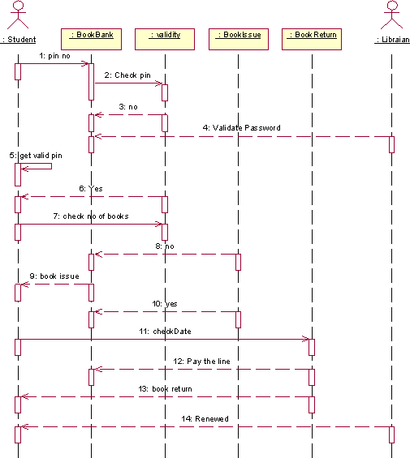

Fig. 6.1. SEQUENCE DIAGRAM FOR DEPOSIT PROCESS

The diagrams show the pin no is entered and check the pin .Get no and validate password check the condition based on condition book issue and return are done. Pay the online and renewed.

5: get valid pin
14: Renewed
: Libraian
4: Validate Password
1: pin no
9: book issue
: Student
7: check no of books 12: Pay the line
13: book return
3: no
11: checkDate
8: no
10: yes
2: Check pin
6: Yes
: validity
: BookReturn
:
BookBank
: BookIssue

Fig. 6.2. COLLABORATION DIAGRAM FOR DEPOSIT PROCESS

- PARTIAL LAYERD LOGICAL ARCHITECTURE DIAGRAM:

UI
Swing | BookBank system | Text | BkBank Console

Domain
Book Details
Validity
Book Bank
Student
Display
Check Validity
Return
Issue
Cancel
St Details
Technical Services
SOAP
Log4J
Persistence
DBFacade

DEPLOYMENT DIAGRAM AND COMPONENT DIAGRAM
Deployment diagrams are used to visualize the topology of the physical components of a system where the software components are deployed.
<<database>>
:MySQL
<<client workstation>>: GenericPC
SQL
HTTP
<<server>> :To mcat6

Fig.8.1.DEPLOYMENT DIAGRAM COMPONENT DIAGRAM
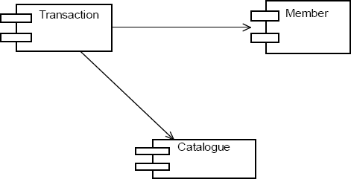
Component diagrams are used to visualize the organization and relationships

Fig.8.2.COMPONENT DIAGRAM
RESULT:
Thus the mini project for Book Bank System has been successfully executed and codes are generated.

Ex no:4

Date:

AIM:
EXAM REGISTRATION SYSTEM

To create a system to perform the Exam Registration system

PROBLEM STATEMENT:

Exam Registration system.is used in the effective dispatch of registration form to all of the students. This system adopts a comprehensive approach to minimize the manual work and schedule resources, time in a cogent manner. The core of the system is to get the online registration form (with details such as name, reg.no etc.,) filled by the student whose testament is verified for its genuineness by the Exam Registration System with respect to the already existing information in the database.

SOFTWARE REQUIREMENT SPECIFICATION: 2.1SOFTWARE INTERFACE
  - Front End Client - The student and Controller online interface is built using
JSP and HTML. The Exam Controller's local interface is built using Java.
  - Web Server - Glassfish application server(SQlCorporation).
  - Back End - SQL database.

2.2HARDWARE INTERFACE
The server is directly connected to the client systems. The client systems have
access to the database in the server.

USECASE DIAGRAM:

The Exam Registration use cases in our system are:
- Login
- View exam details
- View fees details

- Pay fee
- Display details
- Logout

USECASE DIAGRAM :

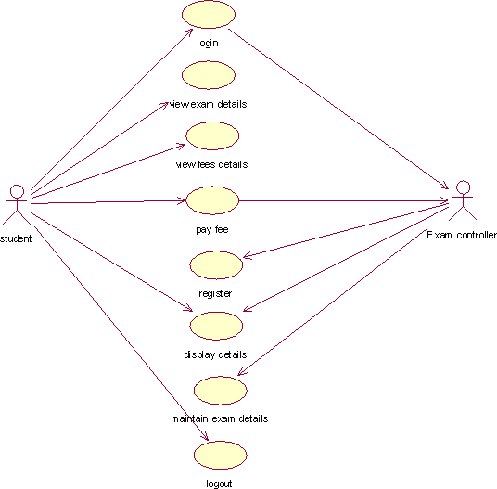

Fig. 3.USECASE DIAGRAM FOR EXAM REGISTRATION SYSTEM

ACTIVITY DIAGRAM:

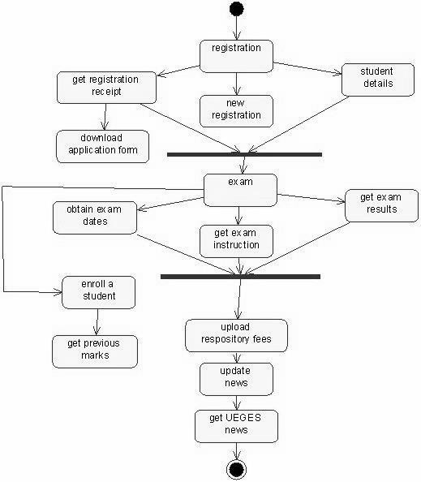

Fig. 4.USECASE DIAGRAM FOR EXAM REGISTRATION SYSTEM

CLASS DIAGRAM:

The class diagram, also referred to as object modeling is the main static analysis diagram. The main task of object modeling is to graphically show what each object will do in the problem domain. The problem domain describes the structure and the relationships among objects.

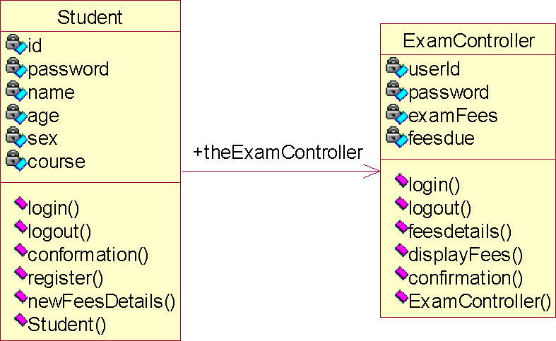

Fig.5. CLASS DIAGRAM FOR EXAM REGISTRATION SYSTEM

- INTERACTION DIAGRAM:

A sequence diagram represents the sequence and interactions of a given USE-CASE or scenario. Sequence diagrams can capture most of the information about the system. Most object to object interactions and operations are considered events and events include signals, inputs, decisions, interrupts, transitions and actions to or from users or external devices.

An event also is considered to be any action by an object that sends information. The event line represents a message sent from one object to another
Database
:
ExamController

Database
: ExamController
: student
1: login
2: confirmation

3: pay
4: register
5: conformation
6: view exam details
7: logout

Fig. 6.1. SEQUENCE DIAGRAM FOR REGISTRATION SYSTEM
5: conformation
3: pay
: student
1: login
2: confirmation
4: register
7: logout
6: view exam details
: ExamController
Database

Fig. 6.2. COLLABORATION DIAGRAM FOR REGISTRATION SYSTEM

- PARTIAL LAYERD LOGICAL ARCHITECTURE DIAGRAM:

UI
Swing | ExamReg System | Text | ExamReg Console

Domain
Student  Register | ViewFeeDetail  Authentication Logout |  | ExamController  Confirmation  Login | Display Fee
Technical Services
SOAP
Log4J
Persistence
DBFacade

DEPLOYMENT DIAGRAM AND COMPONENT DIAGRAM
Deployment diagrams are used to visualize the topology of the physical components of a system where the software components are deployed.

<<database>>
:MySQL

SQL HTTP
<<client workstation>>: GenericPC

<<server>> :To mcat6

Fig.7.1.DEPLOYMENT DIAGRAM COMPONENT DIAGRAM
Component diagrams are used to visualize the organization and relationships among components in a system.

Fig.7.2.COMPONENT DIAGRAM

RESULT:
Thus the mini project for Exam Registration system has been successfully executed and codes are generated.

Ex no: 5

STOCK MAINTENANCE

AIM:
To create a system to perform the Stock maintenance

PROBLEM STATEMENT
The stock maintenance system must take care of sales information of the company and must analyze the potential of the trade. It maintains the number of items that are added or removed.The sales person initiates this Use case. The sales person is allowed to update information and view the database.

SOFTWARE REQUIREMENT SPECIFICATION

  - PURPOSE
The entire process of Stock maintenanceis done in a manual manner Considering the fact that the number of customers for purchase is increasing every year, a maintenance system is essential to meet the demand. So this system uses several programming and database techniques to elucidate the work involved in this process.

SCOPE
    - The System provides an interface to the customer where they can fill in orders for the item needed.
    - The sales person is concerned with the issue of items and can use this system.

    - Provide a communication platform between the customer and the sales person.

TOOLS TO BE USED
    - Eclipse IDE (Integrated Development Environment)
    - Rational Rose tool (for developing UML Patterns)

USE CASE DIAGRAM
The functionality of a system can be described in a number of different use-cases, each of which represents a specific flow of events in a system. It is a graph of actors, a set of use-cases enclosed in a boundary, communication, associations between the actors and the use-cases, and generalizationamong the use-cases

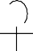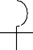
Place Order
Track order
Customer
Validate Customer
Ship Order
Ship Partial Order
Sales Person
Bill Customer

Fig.3. USE CASE DIAGRAM

- ACTIVITY DIAGRAM

It shows organization and their dependence among the set of components. These diagrams are particularly useful in connection with workflow and in describing behavior that has a lot of parallel processing. An activity is a state of doing something: either a real-world process, or the execution of a software routine.

Customer
Sales
Request Service
Pay
Take Order
Fill Order
Deliver Order
Collect Order

Fig.4. ACTIVITY DIAGRAM

- CLASS DIAGRAM

Description:
  - A class diagram describes the type of objects in system and various kinds of relationships that exists among them.
  - Class diagrams and collaboration diagrams are alternate representations of object models.

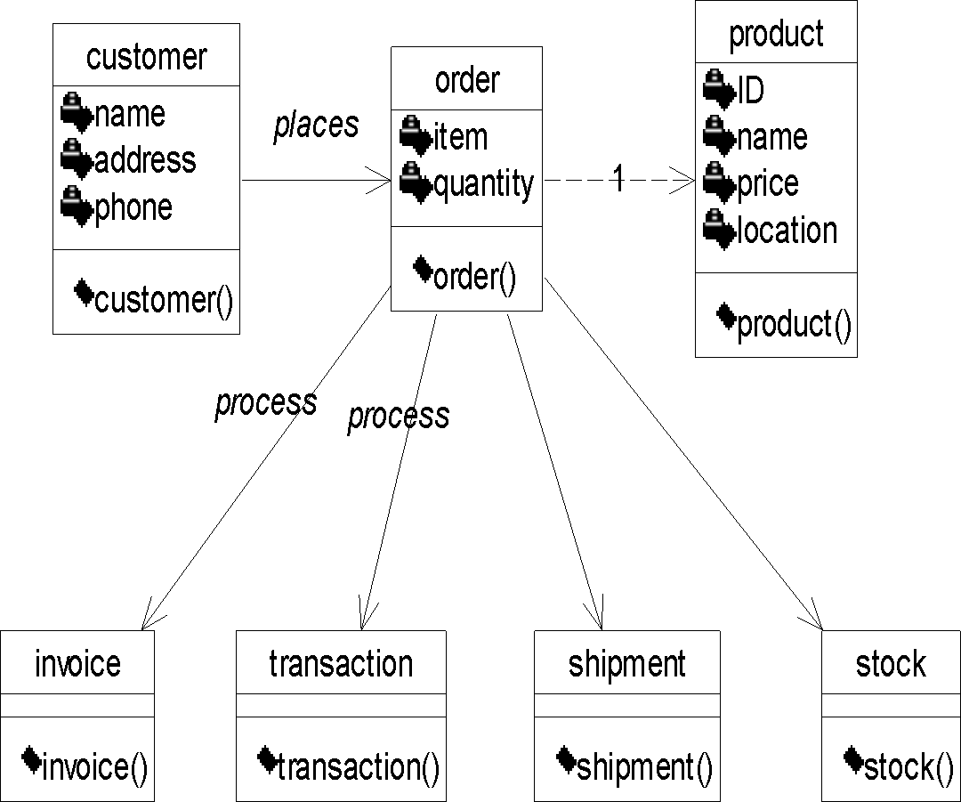

Fig.5. CLASS DIAGRAM

- UML INTERACTION DIAGRAMS

It is the combination of sequence and collaboration diagram. It is used to depict the flow of events in the system over a timeline. The interaction diagram is a dynamic model which shows how the system behaves during dynamic execution.
An Order
An Order
An Order Line
A Stock Item

Prepare
Prepare
Has Stock:=Check
[has Stock]:Remove
Needs reorder:=needs to reorder()
[needs reorder]:new A Reorder Item
[Has Stock]: new
A Delivery Item
A Stock Item
An Order Line
An Order
An Order

Fig.6.1 SEQUENCE DIAGRAM
A Reorder Item
A Delivery Item

COLLABORATION DIAGRAM

Collaboration diagram and sequence diagrams are alternate representations of an interaction. A collaboration diagram is an interaction diagram that shows the order of messages that implement an operation or a transaction.

ORDER ENTRY WINDOW
1: prepare()
AN ORDER

2: *[for all order lines]prepare()
3: hasstock=check

needs Reorder=need to Reorder

4: [hasstock]remove()
STOCK ITEM
ORDER LINE

6: [hasstock]:new

5: [needs Reorder]:new

DELIVERY ITEM
REORDER ITEM

Fig.6.2 COLLABORATION DIAGRAM

- PARTIAL LAYERD LOGICAL ARCHITECTURE DIAGRAM

UI
Text
Swing
StMaint Console
StMain System
Domain
Product
Order
Customer
Shipment
Stock
Invoice
Register

Technical Services

Persistence SOAP Log4J
DBFacade

DEPLOYMENT DIAGRAM AND COMPONENT DIAGRAM

Deployment diagrams are used to visualize the topology of the physical components of a system where the software components are deployed.
LAN
<<database>>
:MySQL
<<client workstation>>: GenericPC

Fig.8.1.DEPLOYMENT DIAGRAM

Component Diagram

Component diagrams are used to visualize the organization and relationships among components in a system.
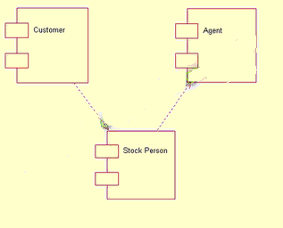

Fig.8.2.COMPONENT DIAGRAM

RESULT:
Thus the mini project for stock maintenance system has been successfully executed and codes are generated.

EX NO: 6 ONLINE COURSE RESERVATION SYSTEM

AIM
To design an object oriented model for course reservation system.

PROBLEM STATEMENT

  - Whenever the student comes to join the course he/she should be provided with the list of course available in the college.

  - The system should maintain a list of professor who is teaching the course. At the end of the course the student must be provided with the certificate for the completion of the course.

SYSTEM REQUIEMENT SPECIFICATION

OBJECTIVES
  - The main purpose of creating the document about the software is to know about the list of the requirement in the software project part of the project to be developed.

SCOPE
  - It specifies the requirement to develop a processing software part that completes the set of requirement.

    - In this specification, we define about the system requirements that are about from the functionality of the system.

    - It tells the users about the reliability defined in usecase specification

FUNCTIONALITY
Many members of the process line to check for its occurrences and transaction, we are have to carry over at sometimes

USABILITY
The user interface to make the transaction should be effectively

PERFORMANCE
It is the capability about which it can performed function for many user at sometimes efficiently (ie) without any ever occurrences

RELIABILITY
The system should be able to the user through the day to day transaction

USERCASE DIAGRAM

  - Use case is a sequence of transaction in a system whose task is to yield result of measurable value to individual author of the system

  - Use case is a set of scenarios together by a common user goal

  - A scenario is a sequence of step describing as interaction between a user and a system

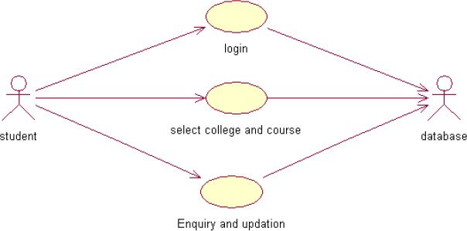

CLASS DIAGRAM:

A class diagram describes the type of objectors in the system the various kinds of static relationship that exist among them.

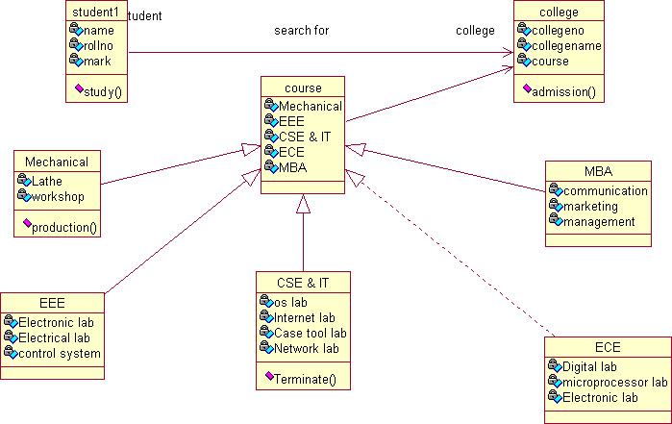

SEQUENCE DIAGRAM

A sequence diagram is one that includes the object of the projects and tells the lifetimes and also various action performed between objects.
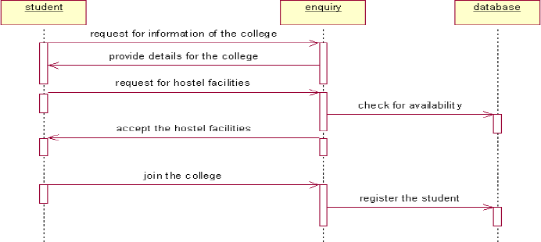

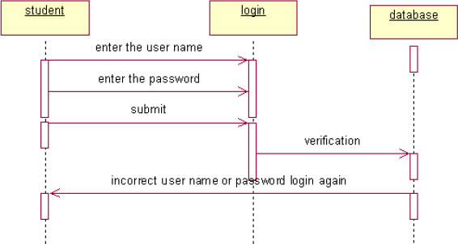
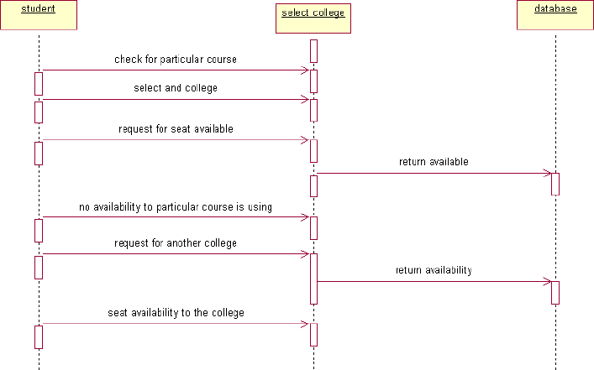

COLLOBORATIION DIAGRAM

It is same as the sequence diagram that involved the project with the only difference that we give the project with the only difference that we give sequence number to each process.

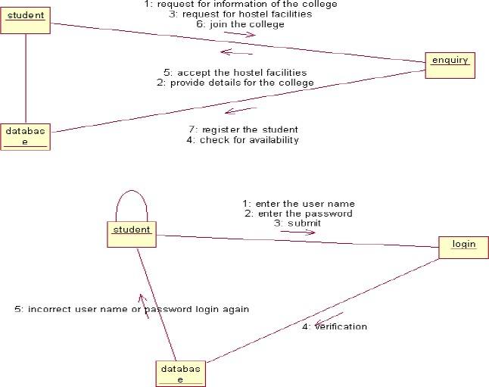

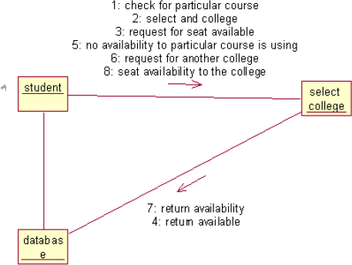

ACTIVIY DIAGRAM

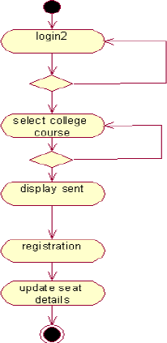
It includes all the activities of particular project and various steps using join and forks

COMPONENT DIAGRAM

The component diagram is represented by figure dependency and it is a graph of design of figure dependency. The component diagram's main purpose is to show the structural relationships between the components of a systems. It is represented by boxed figure. Dependencies are represented by communication association

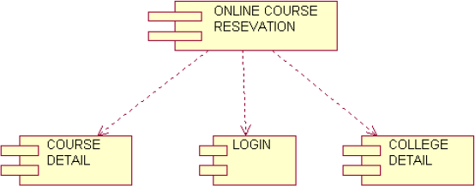

DEPLOYMENT DIAGRAM

It is a graph of nodes connected by communication association. It is represented by a three dimensional box. A deployment diagram in the unified modeling language serves to model the physical deployment of artifacts on deployment targets. Deployment diagrams show "the allocation of artifacts to nodes according to the Deployments defined between them. It is represented by 3-dimentional box. Dependencies are represented by communication association. The basic element of a deployment diagram is a node of two types

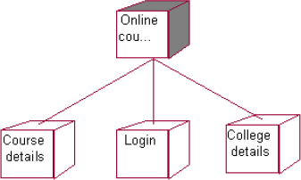

PACKAGE DIAGRAM

A package diagram is represented as a folder shown as a large rectangle with a top attached to its upper left corner. A package may contain both sub ordinate package and ordinary model elements. All uml models and

diagrams are organized into package. A package diagram in unified modeling language that depicts the dependencies between the packages that make up a model. A Package Diagram (PD) shows a grouping of elements in the OO model, and is a Cradle extension to UML. PDs can be used to show groups of classes in Class Diagrams (CDs), groups of components or processes in Component Diagrams (CPDs), or groups of processors in Deployment Diagrams (DPDs).
There are three types of layer. They are

- User interface layer

- Domain layer

- Technical services layer
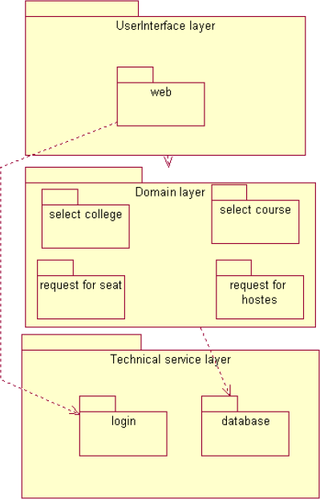

RESULT
Thus, the mini project for online course reservation system has been successfully executed and codes are generated.

EX NO: 7 AIRLINE/RAILWAY RESERVATION SYSTEM

AIM

To develop the Airline/Railway reservation System using Rational Rose Software.

PROBLEM ANALYSIS AND PROJECT PLANNING

In the Airline/Railway reservation System the main process is a applicant have to login the database then the database verifies that particular username and password then the user must fill the details about their personal details then selecting the flight and the database books the ticket then send it to the applicant then searching the flight or else cancelling the process.

OVERALL DESCRIPTION
  - Functionality
The database should be act as an main role of the e-ticketing system it can be booking the ticket in easy way.

Usability
The User interface makes the Credit Card Processing System to be efficient.

Performance
It is of the capacities about which it can perform function for many users at the same times efficiently that are without any error occurrence.

Reliability
The system should be able to process the user for their corresponding request.

USE CASE DIAGRAM
The passenger can view the status of the reserved tickets. So the passenger can confirm his/her travel.

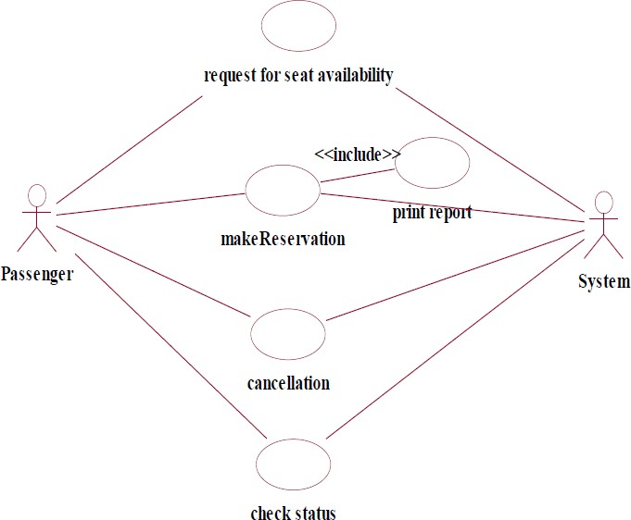

Fig. USE-CASE DIAGRAM FOR AIRLINE RESERVATION

CLASS DIAGRAM

The online ticket reservation system makes use of the following classes:
- ticketReservation
- trainInfo
- passengerInfo
- seatAvailStatus

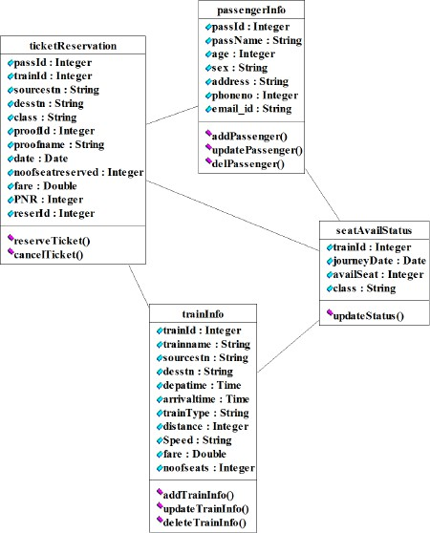

SEQUENCE DIAGRAM

A sequence diagram in Unified Modeling Language (UML) is a kind of interaction diagram that shows how processes operate with one another and in what order. It is a construct of a Message Sequence Chart. There are two dimensions.
- Vertical dimension-represent time.
- Horizontal dimension-represent different objects.

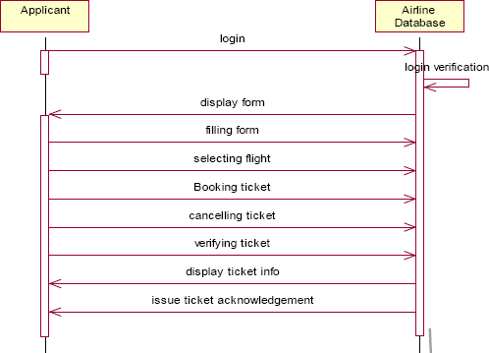

COLLABRATION DIAGRAM

A collaboration diagram, also called a communication diagram or interaction diagram,. A sophisticated modeling tool can easily convert a collaboration diagram into a sequence diagram and the vice versa. A collaboration diagram resembles a flowchart that portrays the roles, functionality and behavior of individual objects as well as the overall operation of the system in real time.
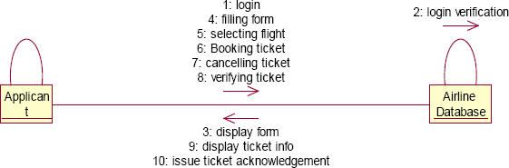

STATE CHART DIAGRAM

The purpose of state chart diagram is to understand the algorithm involved in performing a method. It is also called as state diagram. A state is

represented as a round box, which may contain one or more compartments. An initial state is represented as small dot. A final state is represented as circle surrounding a small dot.

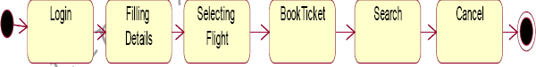

ACTIVITY DIAGRAM
Activity diagrams are graphical representations of workflows of stepwise activities and actions with support for choice, iteration and concurrency. In the Unified Modeling Language, activity diagrams can be used to describe the business and operational step-by-step workflows of components in a system. An activity diagram shows the overall flow of control. An activity is shown as an rounded box containing the name of the operation.

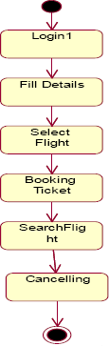

COMPONENT DIAGRAM

The component diagram's main purpose is to show the structural relationships between the components of a system. It is represented by boxed figure. Dependencies are represented by communication association.
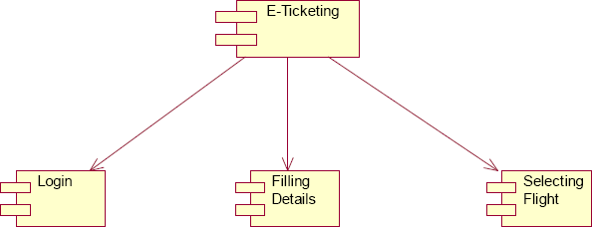

RESULT
Thus the mini project for Airline/Railway reservation System has been successfully executed and codes are generated.

Ex no: 8 SOFTWARE PERSONNEL MANAGEMENT SYSTEM

AIM:
To implement a software for software personnel management system.

PROBLEM STATEMENT:

Human Resource management system project involves new and/or system upgrades of software of send to capture information relating to the hiring termination payment and management of employee. He uses system to plan and analyze all components and performance of metrics driven human resource functions, including recruitment, attendance, compensation, benefits and education. Human resources management systems should align for maximum operating efficiency with financial accounting operations customer relationship management,security and business lines as organization.

( II )SOFTWARE REQUIREMENT SPECIFICATION: 2.1SOFTWARE INTERFACE
  - Front End Client - The applicant and Administrator online interface is built using
JSP and HTML. The HR's local interface is built using Java.
  - Server - Glassfish application server(SQL Corporation).
  - Back End - SQL database.

2.2HARDWARE INTERFACE
The server is directly connected to the client systems. The client systems have access to the database in the server.

( III )USECASE DIAGRAM:

The HR of an organization involves recruitment training, monitoring and motivation of an employee. The HR also involves gives salary as observed in the payroll sheet. The employee undergoes training, receives the salary , gives the expected performance and manages time in order to complete a given task within the required period.

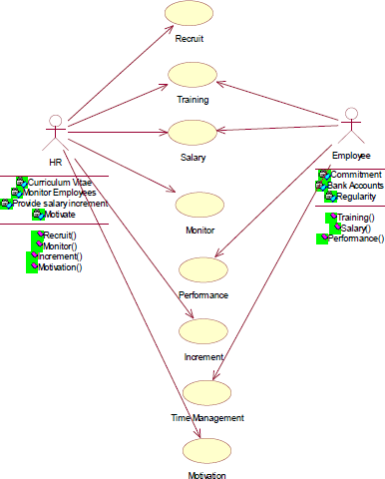

Fig.3. USE CASE DIAGRAM

- ACTIVITY DIAGRAM:

The activity diagram notation is an action, partition, fork join and object node. Most of the notation is self explanatory, two subtle points. Once an action finished, there is an automatic outgoing transaction. The diagram can show both control flow and data flow.

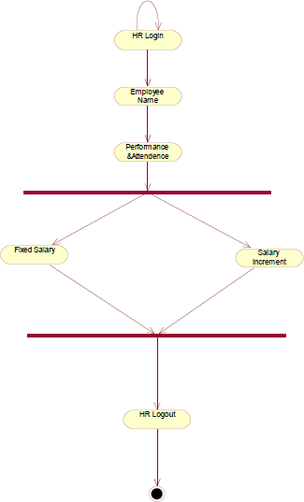

Fig.4. ACTIVITY DIAGRAM

- CLASS DIAGRAM:

The class diagram, also referred to as object modeling is the main static analysis diagram. The main task of object modeling is to graphically show what each object will do in the problem domain. The problem domain describes the structure and the relationships among objects.

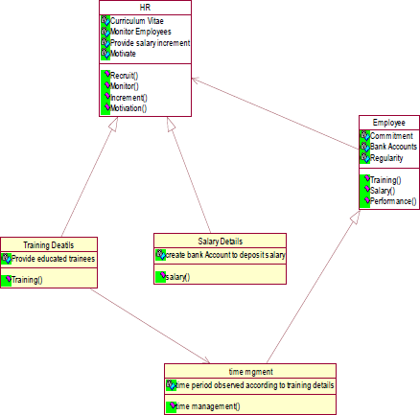

Fig.5.CLASS DIAGRAM

- INTERACTION DIAGRAM:

A sequence diagram represents the sequence and interactions of a given USE-CASE or scenario. Sequence diagrams can capture most of the information about the system. Most object to object interactions and operations are considered events and events include signals, inputs, decisions, interrupts, transitions and actions to or from users or external devices.

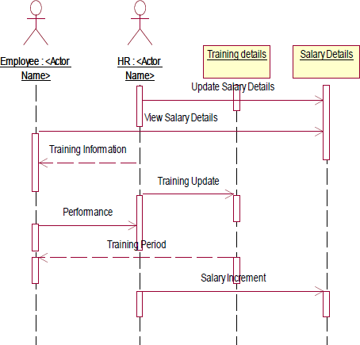

Fig.6.1.SEQUENCE DIAGRAM

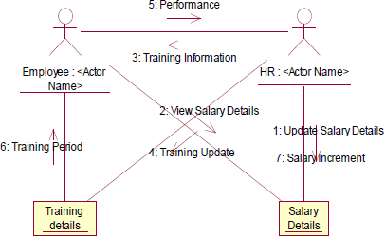

Fig.6.2.COLLABORATION DIAGRAM

State Transition Diagram
States of object are represented as rectangle with round corner, the transaction between the different states. A transition is a relationship between two state that indicates that when an event occur the object moves from the prior state to the subsequent.

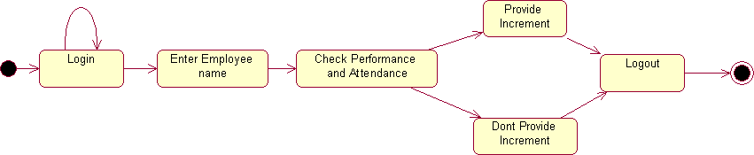

Fig.7.STATE TRANSITION DIAGRAM

- DEPLOYMENT DIAGRAM AND COMPONENT DIAGRAM

HR recruits employee for a company employee recruited by HR goes under training before actually working. Training period is given to the employee with the training details. The salary details for the employee are provided.

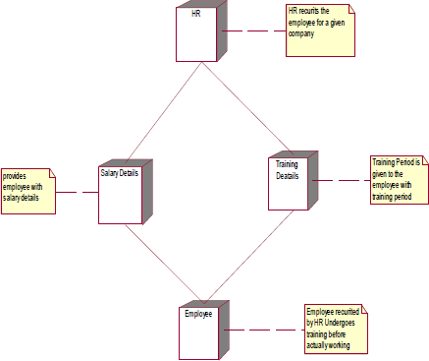

Fig.8.1.DEPLOYMENT DIAGRAM

COMPONENT DIAGRAM

The HR recruits, motivate and monitor the employee, HR also update the salary details and training details for reference. The employee are those who are recruited by HR and work for the company. The training details provide employees with training details which is updated by HR

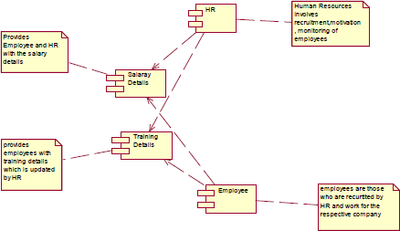

Fig.8.2.COMPONENT DIAGRAM

RESULT:

Thus the mini project for software personnel management system has been successfully executed and codes are generated.

Ex. No:9

CREDIT CARD PROCESSING

AIM:
To create a system to perform the credit card processing

(I) PROBLEM STATEMENT:

Credit card processing through offline involves the merchant collecting order information (including credit card numbers), storing this in a database on your site, and entering it using their on-site merchant credit card processing system. Takes time to manually enter credit card information for each order. This solution creates following cons:

( II )SOFTWARE REQUIREMENT SPECIFICATION:

  - PRODUCT PERSPECTIVE

This solution involves signing up for a free Business Account. Once this is done and the e-commerce site is properly configured, you can accept payments from Visa, MasterCard, Amex, and Discover cards payments.

SOFTWARE INTERFACE
    - Front End Client - The applicant and Administrator online interface is built using
JSP and HTML. The Administrators's local interface is built using Java.
    - Web Server - Glassfish application server(SQL Corporation).
    - Back End - SQL database.

HARDWARE INTERFACE

The server is directly connected to the client systems. The client systems have access to the database in the server.

( III )USECASE DIAGRAM:

USE-CASE NAME: PAYMENT APPROVAL

The transaction details are recorded by the credit card processor and results are securely relayed to the merchant. Merchant’s site receives transaction result and does appropriate actions (e.g. saves the order & shows message).
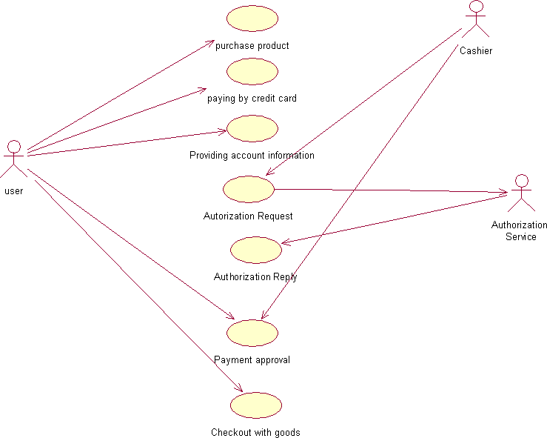

Fig.3. USECASE DIAGRAM FOR PASSPORT AUTOMATION SYSTEM
- CLASS DIAGRAM:

The class diagram, also referred to as object modeling is the main static analysis diagram. The main task of object modeling is to graphically show what each object will do in the problem domain. The problem domain describes the structure and the relationships among objects.
The Credit Card Processing system class diagram consists of three classes.
They are
Cashier User
Authorization Service

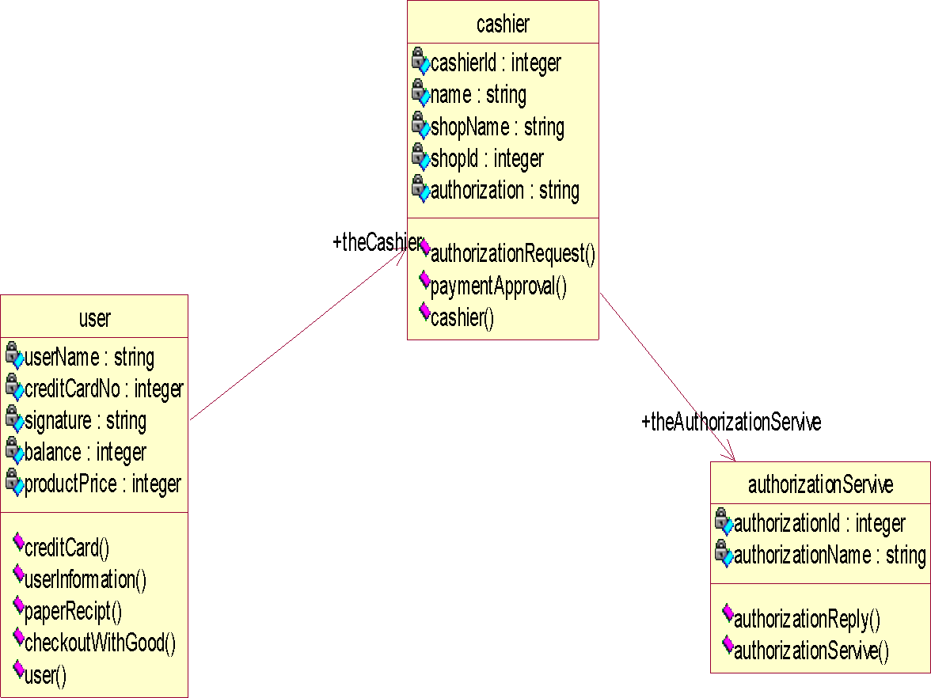

Fig.4.CLASS DIAGRAM

- INTERACTION DIAGRAM:

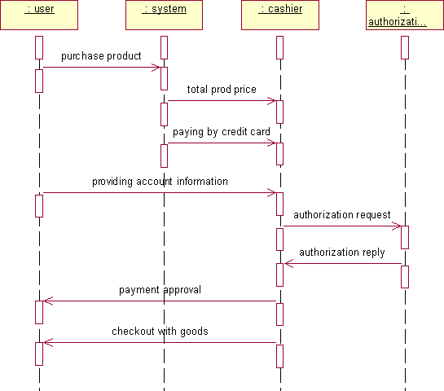

Fig.5.1.SEQUENCE DIAGRAM

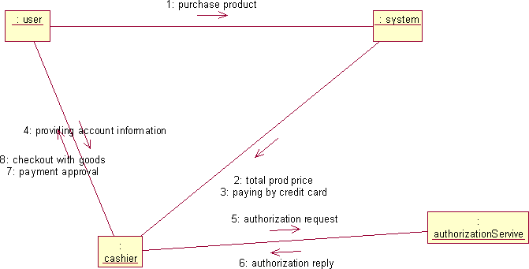

Fig.5.2.COLLABORATION DIAGRAM

PARTIAL LAYERD LOGICAL ARCHITECTURE DIAGRAM

UI
Swing
CCP system

Domain
User Purchase | Account Info  AutherizationSerivic e  Reply |  | Merchant Request | Receipt

Technical Services

Persistence
DBFacade

SOAP
Log4J

- DEPLOYMENT DIAGRAM AND COMPONENT DIAGRAM
Deployment diagrams are used to visualize the topology of the physical components of a system where the software components are deployed.

<<database>
>
: SQL

SQ HT
<<client workstation
>>:Generic

<<server>>

Fig.7.1.DEPLOYMENT DIAGRAM

COMPONENT DIAGRAM
Component diagrams are used to visualize the organization and relationships among components in a

Fig.7.2.COMPONENT DIAGRAM
RESULT:

Thus the mini project for credit card processing system has been successfully executed and codes are generated.

Ex. No:10

AIM:

OOK MANAGEMENT SYSTEM

To create a system to perform E- book Management System.

PROBLEM STATEMENT:

An E- Book lends books and magazines to member, who is registered in the system. Also it handles the purchase of new titles for the Book Bank. Popular titles are brought into multiple copies. Old books and magazines are removed when they are out or date or poor in condition. A member can reserve a book or magazine that is not currently available in the book bank, so that when it is returned or purchased by the book bank, that person is notified. The book bank can easily create, replace and delete information about the tiles, members, loans and reservations from the system.

SOFTWARE RESOURCE SPECIFICATION:

  - OVERALL DESCRIPTION

Itwill describe major role of the system components and inter- connections.

PRODUCT PERSPECTIVE

The ORS acts as an interface between the user and the 'e-book manager'. This system tries to make the interface as simple as possible and at the same time not risking the security of data stored in. This minimizes the time duration in which the user receives the books or magazines.

SOFTWARE INTERFACE

Front End Client - The Student and Librarian online interface is built using JSP and HTML. The Librarians local interface is built using Java.

Web Server - Glassfish application server (Oracle Corporation).

Back End - Oracle database

HARDWARE INTERFACE

The server is directly connected to the client systems. The client systems have access to the database in the server.

USE-CASE DIAGRAM:

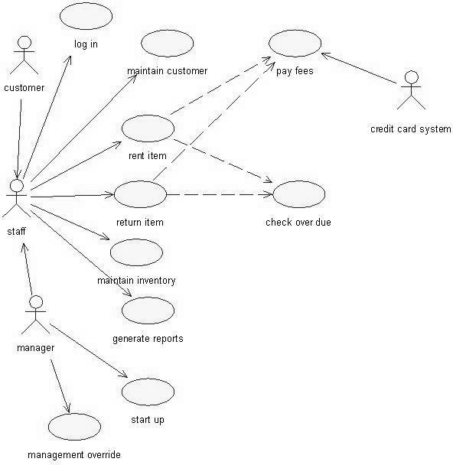

Fig.3.USE-CASE DIAGRAM FOR E-BOOK SYSTEM

ACTIVITY DIAGRAM:

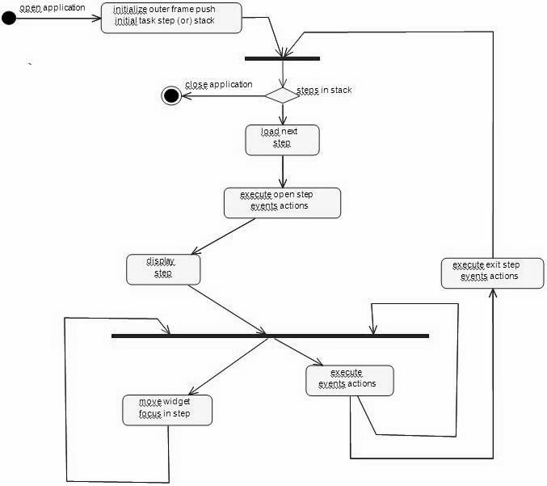

    - CLASS DIAGRAM

The class diagram, also referred to as object modeling is the main static analysis diagram. The main task of object modeling is to graphically show what each object will do in the problem domain. The problem domain describes the structure and the relationships among objects.

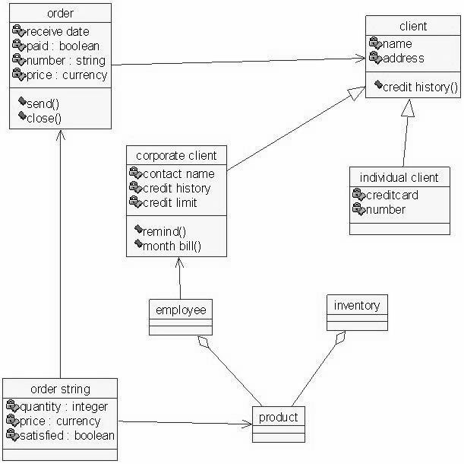

Fig.5.CLASS DIAGRAM FOR E-BOOK SYSTEM

    - INTERACTION DIAGRAM:

A sequence diagram represents the sequence and interactions of a given USE-CASE or scenario. Sequence diagrams can capture most of the information about the system. Most object to object interactions and operations are considered events and events include signals, inputs, decisions, interrupts, transitions and actions to or from users or external devices.

An event also is considered to be any action by an object that sends information. The event line represents a message sent from one object to another, in which the “form” object is requesting an operation be performed by the “to” object. The “to” object performs the operation using a method that the class contains.

It is also represented by the order in which things occur and how the objects in the system send message to one another.

The sequence diagram and collaboration diagram are given below.

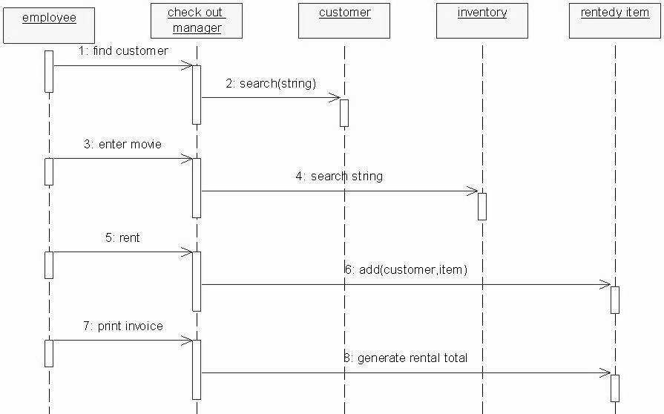

Fig.6.1.SEQUENCE DIAGRAM

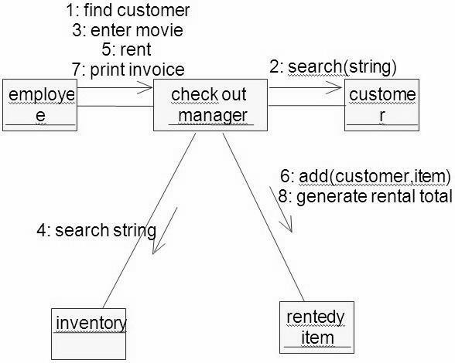

Fig.6.2.COLLABORATION DIAGRAM

PARTIAL LAYERD LOGICAL ARCHITECTURE DIAGRAM
UI
Swing
E-Book system

Domain
Client bill | Credit History |  | Order Process | Balance
Technical Services
Log4J
SOAP
Persistence
DBFacade

    - DEPLOYMENT DIAGRAM AND COMPONENT DIAGRAM
Deployment diagrams are used to visualize the topology of the physical components of a system where the software components are deployed.
<<database>>
:MySQL
<<client workstation>>: GenericPC
SQL
HTTP
<<server>> :To mcat6

Fig.8.1.DEPLOYMENT DIAGRAM COMPONENT DIAGRAM
Component diagrams are used to visualize the organization and relationships among components in a system.

Fig.8.2.COMPONENT DIAGRAM
RESULT:
Thus the mini project for E-Book System has been successfully executed and codes are generated.

Ex.No: 11

RECRUITMENT SYSTEM

AIM:
To create an automated system to perform the Recruitment System
Process.

PROBLEM STATEMENT:
The recruitment system allows the job seekers to enroll their names through the process of registration. The employee also can get the list of available candidates and shortlist for their company requirement. Once the applicant enrolls he receives an id, which helps him in further Correspondence. A fees amount is received from the job seekers for enrollment. This system makes the task of the job seeker easier rather than waiting in queue for enrollment. This also reduces the time consumption for both for the job seeker and employee.

SOFTWARE REQUIREMENT SPECIFICATION:

  - PRODUCT PERSPECTIVE
The PAS acts as an interface between the 'applicant' and the 'administrator'. This system tries to make the interface as simple as possible and at the same time not risking the security of data stored in. This minimizes the time duration in which the user receives the recruitment.

SOFTWARE INTERFACE
    - Front End Client - The applicant and Administrator online interface is built using JSP and HTML. The Administrators's local interface is built using Java.
    - Web Server - Glassfish application server (SQL Corporation).

    - Back End - SQL database.

HARDWARE INTERFACE
The server is directly connected to the client systems. The client systems have access to the database in the server.

( III )USECASE DIAGRAM:

The Recruitment Automation system use cases are:

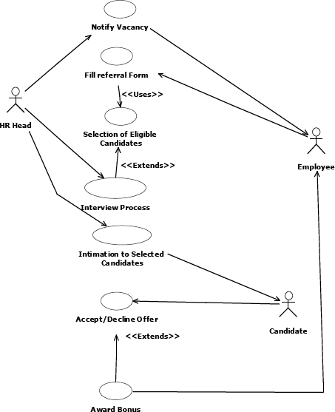

Fig.3. UML USE CASE DIAGRAM

- ACTIVITY DIAGRAM:

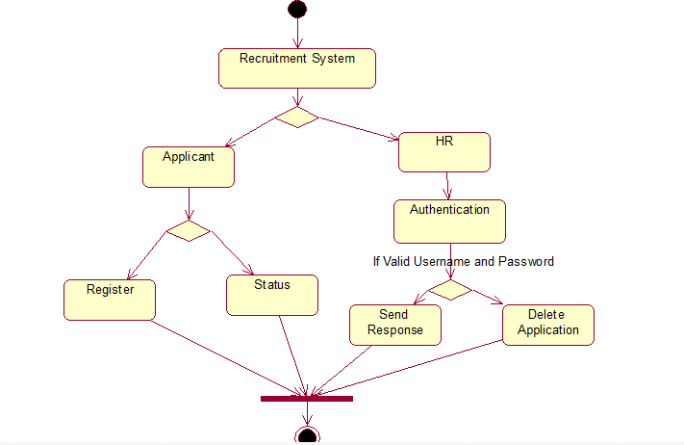

Fig.4. ACTIVITY DIAGRAM

- UML CLASS DIAGRAM:
The UML class diagram is to illustrate class interfaces and their actions. They are used for static object modeling, we have already introduced and used their UML diagram while domain modeling.

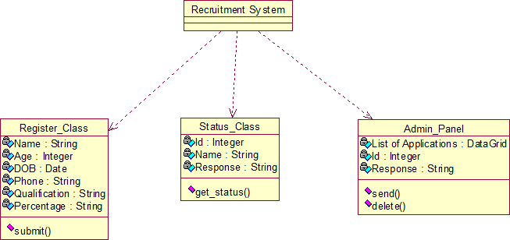

Fig.5. UML CLASS DIAGRAM

- UML SEQUENCE DIAGRAM:

A sequence diagram illustrates a kind of format in which each object interacts via message. It is generalize between two or more specialized diagram.

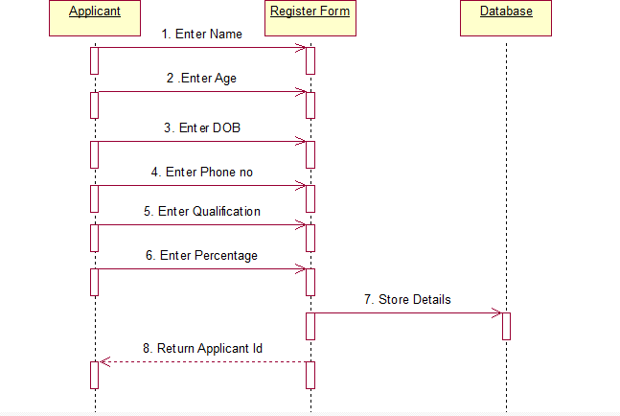

Fig. 6.1SEQEUENCE DIAGRAM FOR Register:

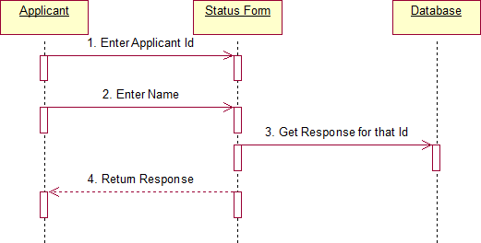

Fig.6.2. SEQUENCE DIAGRAM FOR STATUS

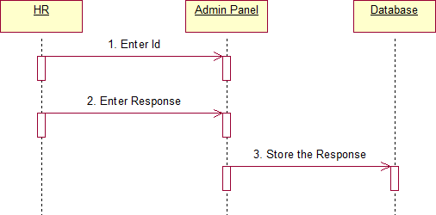

Fig.6.3. SEQUENCE DIAGRAM FOR Admin
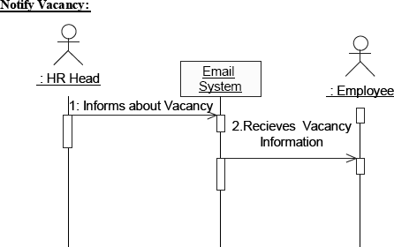

- UML COLLABRATION DIAGRAM:
Communication diagram illustrate that object interact on a graph or network format in which object can be placed where on the diagram. In collaboration diagram the object can be placed in anywhere on the diagram. The collaboration comes from sequence diagram.

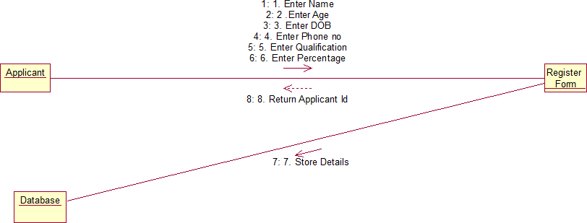

Fig.7.1COLLABRATION DIAGRAM For Register

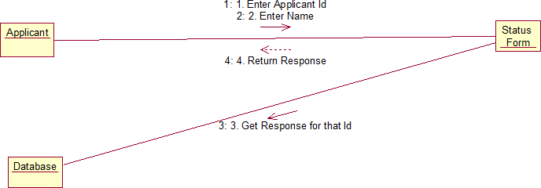

Fig.7.2. COLLABORATION DIAGRAM FOR Status

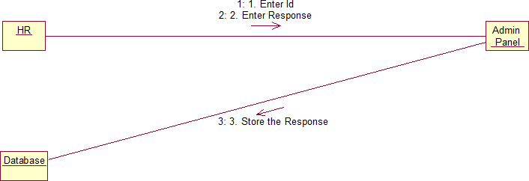

Fig.7.3.COLLABORATION DIAGRAM FOR Admin
- PARTIAL LAYERD LOGICAL ARCHITECTURE DIAGRAM:
UI
Swing | Recruitment system | Text | Recruitment Form

Domain
Candidate Submit | Cancel  Status |  | Admin panel  send  Get status | delete
Technical Services
SOAP
Log4J
Persistence
DBFacade

DEPLOYMENT DIAGRAM AND COMPONENT DIAGRAM
Deployment diagrams are used to visualize the topology of the physical components of a system where the software components are deployed.
<<databas e>>
:MySQL
<<client workstati on>>:Gen
SQ
H
<<server>
> :Tomca t6

Fig.9.1.DEPLOYMENT DIAGRAM

Component Diagram
Component diagrams are used to visualize the organization and relationships among components in a system.

Fig.9.2.COMPONENT DIAGRAM

RESULT:
Thus the mini project for recruitment system has been successfully executed and codes are generated.

Ex.No :12 FOREIGN TRADING SYSTEM

AIM
To design a project Foreign Trading System using Rational Rose
Software and to implement the software in Visual Basic

PROBLEM STATEMENT

The steps involved in Foreign Trading System are:

The forex system begins its process by getting the username and password from the trader. After the authorization permitted by the administrator, the trader is allowed to perform the sourcing to know about the commodity details.After the required commodities are chosen, the trader places the order.The administrator checks for the availability for the required commodities and updates it in the database. After the commodities are ready for the trade, the trader pays the amount to the administrator.The administrator in turn provides the bill by receiving the amount and updates it in the database.The trader logouts after the confirmation message has been received.

SOFTWARE REQUIREMENT SPECIFICATION

ADMINISTRATOR | One who coordinates the entire trading process.
DATABASE | All the transaction details are stored here.
READER | Person who is viewing the website.
USER | The traders and the viewers are the users.
SOFTWARE REQUIREMENT SPECIFICATION | This software specification documents full set of features and function for foreign trading system.

FUNCTIONALITY
Transfer purchasing power between countries. Obtain credit for international trade transactions. Minimize exposure to the risks of exchange rate changes.

FUNCTIONALITY REQUIREMENTS
Functional requirements refers to the functionality of the system. The services that are provided to the trader who trades.

UML DIAGRAMS
The exporter submits the relevant documents to his buyer (banker) for getting the payment for the goods exported.
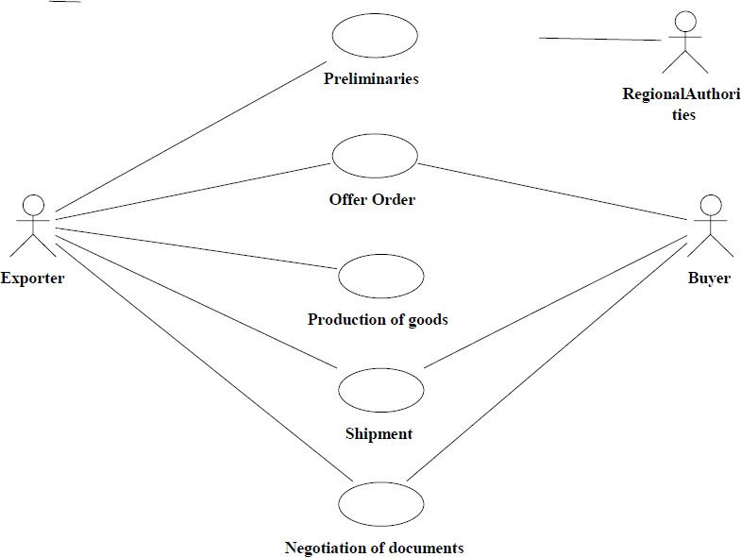

USE CASE DIAGRAM CLASS DIAGRAM
A class diagram is a type of static structure diagram that describes the structure of a system. The classes in the class diagram represent both the main objects and or interactions in the application.The class diagram is represented using rectangular boxes each of which contains three parts:

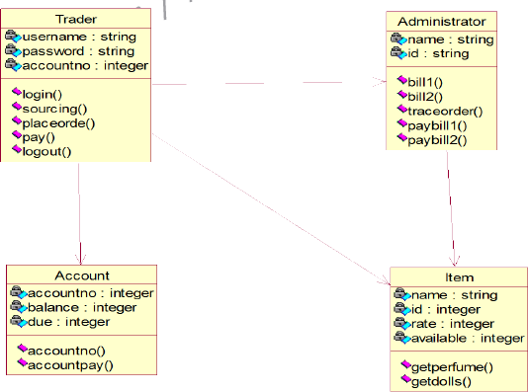

SEQUENCE DIAGRAM

A sequence diagram in unified modeling language is a kind of interaction diagram that shows how processes operate with one another and in what order. It is a construct of a Message Sequence Chart. Sequence diagrams are sometimes called event diagrams, event scenarios, and timing diagrams. This diagram shows a parallel vertical lines called lifelines. There are two dimensions in this diagram

- Vertical dimension-represents time.

- Horizontal dimension-represent different object

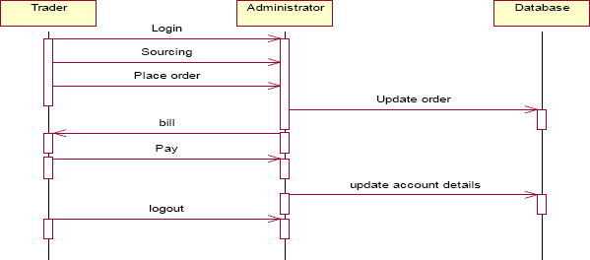

TraderTraderAdministratorAdministratorDatabaseDatabaseLoginSourcingPl ace orderUpdateorderPay update account details bill logout

COLLABORATION DIAGRAM
A collaboration diagram belongs to a group of UML diagrams called Interaction Diagrams. collaboration diagrams, like sequence diagrams, show how the objects interact over the course of time. collaboration diagrams show the sequence by numbering the messages on the diagram.

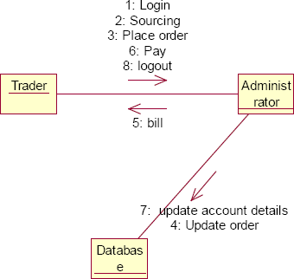

DOCUMENTATION OF COLLABORATION DIAGRAM
The collaboration diagram shows how the trader performs the sourcing and places order for which the administrator provides the bill and updates it in the database.

STATE CHART DIAGRAM
The state chart is used to model dynamic nature of a system. They define different states of an object during its lifetime. And these states are changed by events. So these diagrams are useful for reactive systems i.e.., a system that responds to external or internal events. It describes the flow of control from one state to other state. The initial state is represented using the small dot. The final state is represented using a circle surrounded by a small dot

DOCUMENTATION OF STATE CHART DIAGRAM
The state diagram represents the following states.

- The trader logins the register in the first state and performs sourcing in the second state.

- The trader places the order in the third state.

- The trader receives the bill in the fourth state and pay the required amount in fifth state.
- The trader logouts from the system in the sixth state

ACTIVITY DIAGRAM
This diagram represents the graphical representation of workflows of stepwise activities and actions with support for choice, iteration and concurrency. It shows the overall flow of control.

DOCUMENTATION OF ACTIVITY DIAGRAM
This activity diagram represents the flow of stepwise activities performed in foreign trading system.

- The first action represents the trader logins to the system.

- The second action is the place where the trader places the order.

- The decision state is the state where the trader decides to place the order.

- If the trader places the order, fill the form for the required commodities.

- The next activity is that the administrator provides the bill for those commodities.

- The trader pays for the bill and logout from the system.

COMPONENT DIAGRAM
A component diagram depicts how the components are wired together to form larger components and or software systems. Components are wired together by using an assembly connector to connect the required interface of one component with the provided interface of another component.
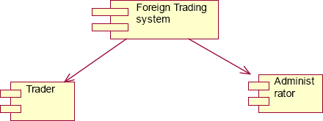

DOCUMENTATION OF COMPONENT DIAGRAM
The main component in the component diagram is foreign trading system. The trader who come to do the trading process and administrator who manages all the other processes is the sub components.

DEPLOYMENT DIAGRAM
A deployment diagram models the physical deployment of artifacts on nodes. The nodes appear as boxes, and the artifacts allocated to each node appear as rectangles within the boxes. Nodes may have sub nodes, which appear as nested boxes.

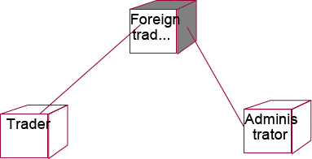

DOCUMENTATION OF DEPLOYMENT DIAGRAM
The processor in this diagram is the foreign trading system. The devices are the trader and administrator who perform the main activities in the system.

PACKAGE DIAGRAM
A package diagram in the unified modeling language depicts the dependencies between the packages that make up a model. It provides a way to group the elements. There are three types of layers in package diagram. They are

- User interface layer

- Domain layer

- Technical services layer

User interface layer
The user interface layer may call upon its directly subordinate application logic layer, and also upon elements of a lower technical service layer, for logging and so forth.

Domain layer
Software objects representing domain concepts (for example, a software class administrator) that fulfill application requirements, such as tracing order and providing the bill.

Technical services layer

General purpose objects and subsystems that provide supporting technical services, such as interfacing with a database or error logging.These services are usually application-independent.

DOCUMENTATION OF PACKAGE DIAGRAM
The three layers in the foreign trading system are

- User interface layer – consists of web and login. This layer describes how the trader logins to the website and trades for the commodities.

- Domain layer – shows the activities that are performed inside the trading system. The activities are place order, pay for the bill and logouts.

- Technical service layer – The sourcing and updating the details are performed in this layer.

RESULT
Thus the mini project for foreign trading system has been successfully executed and codes are generated.

Ex. No: 13 CONFERENCE MANAGEMENT SYSTEM

AIM
To develop a project on Conference management system using
Rational Rose Software.

( I )PROBLEM STATEMENT
The process of the candidates is to login the conference system and submit the paper through online. Then the reviewer reviews the paper and sends the acknowledgement to the candidate either paper selected or rejected. This process of on conference management system are described sequentially through following steps,

- The candidate login to the conference management system.

- The paper title is submitted.

- The paper is been reviewed by the reviewer.

- The reviewer sends acknowledgement to the candidate.

- Based on the selection, the best candidate is selected.

- Finally the candidate registers all details.

(II )SOFTWARE REQUIREMENT SPECIFICATION

CANDIDATE | The candidate can login and submit the paper to the reviewer. After getting acknowledgement the candidate will submit the revised and camera ready paper then registration process  will be carried out.
REVIEWER | Reviewer will reviews the paper and sending acknowledgement to the candidate
DATABASE | Database is used to verify login and store the details of selected candidates.

SOFTWARE REQUIREMENT SPECIFICATION | This software specification documents full set of features  and function for conference management system.

PURPOSE
The purpose of the conference management system is that the system can easily review the process. The main process in this document is the submission of paper by the candidate, reviewing process by the reviewer and sending of acknowledgement to the candidates whose paper is selected.

SCOPE
The scope of this conference management process is to select the best candidate from the list of candidates based on their performance in the process.

FUNCTIONALITY
The main functionality of conference system is to select the candidate for the presentation in conference.

USABILITY
The user interface to make the process should be effective that is the system will help the candidates to register easily. The system should be user friendly.

PERFORMANCE
It describes the capability of the system to perform the conference process of the candidate without any error and performing it efficiently.

RELIABILITY
The conference system should be able to serve the applicant with correct information and day-to-day update of information.

FUNCTIONAL REQUIREMENTS
Functional requirements are those that refer to the functionality of the system that is the services that are provided to the candidate who register for the conference.

UML DIAGRAMS

The following UML diagrams describe the process involved in the conference management system.

USE CASE DIAGRAM

A use case is a methodology used in system analysis to identify, clarify, and organize system requirements. The use case is made up of a set of possible sequences of interactions between systems and users in a particular environment and related to a particular goal. It is represented using ellipse. Actor is any external entity that makes use of the system being modeled. It is represented using stick figure.

DOCUMENTATION OF USE CASE DIAGRAM
The actors in this use case diagram are candidate, reviewer and database. The use cases are the activities performed by actors.
The actors in this use case diagram are

- Candidate - Logins the conference system and submits the paper then do the registration process.

- Reviewer – Review the paper , select best candidate and send acknowledgement to them.

- Databases - verify the login and register details and selected candidate details are stored in it.

The use cases in this use case diagram are

- Login - Candidate enter their username and password to login to the conference system.

Paper sumbission– Candidate submits the paper.

- Review the paper– The paper is been reviewed by the reviewer and the paper is selected.

- Paper confirmation details – The reviewer can send the confirmation details to the candidate.

- Revised and camera ready paper – After the paper is selected and the camera ready paper should be submitted to the reviewer by candidate.

- Registration – After submitting the revised paper the candidate wants to register.
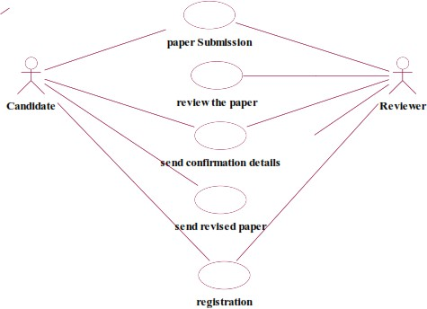

CLASS DIAGRAM

A class diagram in the unified modeling language (UML) is a type of static structure diagram that describes the structure of a system by showing the system's classes, their attributes, and the relationships between the classes. It is represented using a rectangle with three compartments. Top compartment have the class name, middle compartment the attributes and the bottom compartment with operations.

DOCUMENTATION OF CLASS DIAGRAM
This class diagram has three classes candidate, reviewer and database.

- Candidate – Its attributes are name ,collegename , department , paper title. The operations performed in the candidate class are login, submit the paper, submit revised and camera ready paper and registration.

- Reviewer – Its attributes are name, department, reviewer ID The operations performed are review the paper and send the paper confirmation details.

- Database –The operations performed are storing candidate details and verifying login .

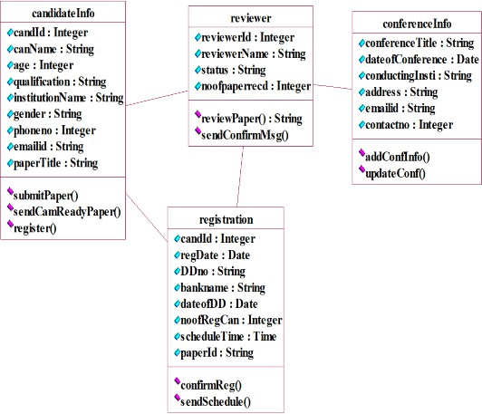

SEQUENCE DIAGRAM

A sequence diagram in Unified Modeling Language (UML) is a kind of interaction diagram that shows how processes operate with one another and in what order. It is a construct of a Message Sequence Chart. There are two dimensions.
- Vertical dimension-represent time.
- Horizontal dimension-represent different objects.

SEQUENCE DIAGRAM FOR SUBMITTING PAPER
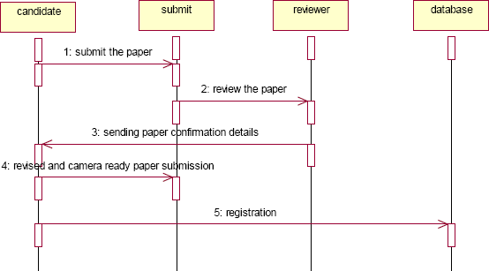

DOCUMENTATION OF SEQUENCE DIAGRAM LOGIN
This sequence diagram describes the sequence of steps to show

- The candidate login in to the conference system and register for job.

- The verification done in the database .

PAPER SUBMISSION
This sequence diagram shows steps to show

- The candidate sumbit the paper.

- The reviewer reviews the paper and sends acknowlegement to the candidate.

- The candidate submits revised and camera ready paper.

- This candidate will registers their detials.

COLLABRATION DIAGRAM

A collaboration diagram, also called a communication diagram or interaction diagram,. A sophisticated modeling tool can easily convert a collaboration diagram into a sequence diagram and the vice versa. A collaboration diagram resembles a flowchart that portrays the roles, functionality and behavior of individual objects as well as the overall operation of the system in real time.

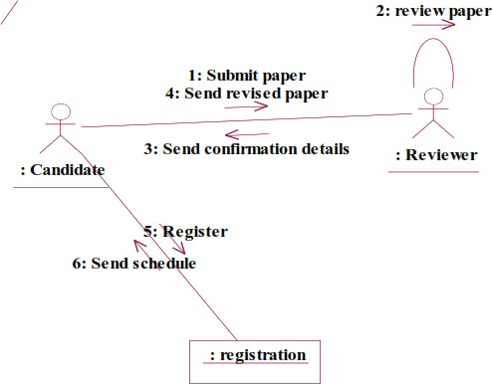

DOCUMENTATION OF COLLABRATION DIAGRAM LOGIN
This collaboration diagram is to show how the applicant login in the conference system. Here the sequence is numbered according to the flow of execution.

PAPER SUBMISSION
This collaboration diagram is to show the submitting paper process of the candidate for the conference. The flow of execution of this selection process is represented using the numbers.

STATE CHART DIAGRAM

The purpose of state chart diagram is to understand the algorithm involved in performing a method. It is also called as state diagram. A state is represented as a round box, which may contain one or more compartments. An initial state is represented as small dot. A final state is represented as circle surrounding a small dot.

DOCUMENTATION OF STATE CHART DIAGRAM
This state diagram describes the behaviour of the system.

- First state is login where the candidate login to the conference system.

- The next state is submitting the paper .

- Then review the paper if it is selected the process will continue..

- The candidate should submit revised and camera ready paper.

ACTIVITY DIAGRAM

Activity diagrams are graphical representations of workflows of stepwise activities and actions with support for choice, iteration and concurrency. In the Unified Modeling Language, activity diagrams can be used to describe the business and operational step-by-step workflows of components in a system. An activity diagram shows the overall flow of control. An activity is shown as an rounded box containing the name of the operation.

DOCUMENTATION OF ACTIVITY DIAGRAM

This activity diagram flow of stepwise activities performed in recruitment system.

- First the candidate login to the database.

- Then the candidate should submit the paper.

- If it is selected the acknowledgement will send to the candidate.

- After submitting revised paper the registration proces will be done.

COMPONENT DIAGRAM

The component diagram's main purpose is to show the structural relationships between the components of a system. It is represented by boxed figure. Dependencies are represented by communication association.
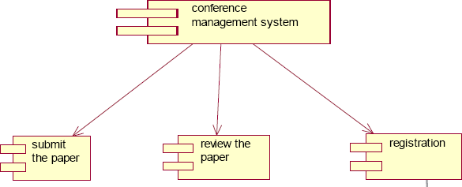

DOCUMENTATION OF COMPONENT DIAGRAM
The main component in this component diagram is conference management system. And submit the paper, review the paper and registration.

DEPLOYMENT DIAGRAM

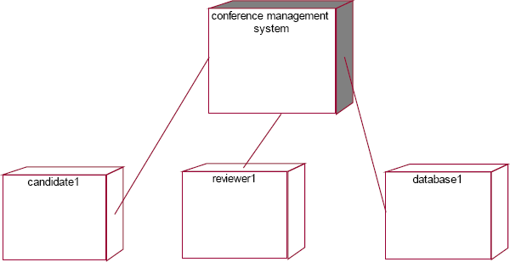
A deployment diagram in the unified modeling language serves to model the physical deployment of artifacts on deployment targets. Deployment diagrams show "the allocation of artifacts to nodes according to the Deployments defined between them. It is represented by 3-dimensional box. Dependencies are represented by communication association.

DOCUMENTATION OF DEPLOYMENT DIAGRAM
The processor in this deployment diagram is the conference management system which is the main part and the devices are the candidate, appear for do conference , reviewer will reviews paper , database will store all details which are the some of the main activities performed in the system.

PACKAGE DIAGRAM

A package diagram in unified modeling language that depicts the dependencies between the packages that make up a model. A Package Diagram (PD) shows a grouping of elements in the OO model, and is a Cradle extension to UML. PDs can be used to show groups of classes in Class Diagrams (CDs), groups of components or processes in Component Diagrams (CPDs), or groups of processors in Deployment Diagrams (DPDs).

DOCUMENTATION OF PACKAGE DIAGRAM
The three layers in the online recruitment system are

- The User interface layer - consists of the web and login. This layer describes how the candidate login.

- The Domain layer – shows the activities that are performed in the conference management system. The activities are paper submission , review paper , registration.

- The Technical service layer - the verification details and the selected candidate details will stored into the database.

RESULT

Thus the mini project for Conference management system has been successfully executed and codes are generated.

Ex.No:14 BPO MANAGEMENT SYSTEM

AIM:
To implement a software for BPO management system

PROBLEM STATEMENT:
With the reduction in communication costs and improved bandwidths and associated infrastructure, BPO as a segment is witnessing a massive growth. One of the key challenges that BPO companies that provide data entry/data validation services is an efficient and effective way of getting the source documents from different customers and accurately route the same to different operators for processing.

SOFTWARE REQUIREMENT SPECIFICATION:
  - PRODUCT PERSPECTIVE
The BPOS acts as an interface between the 'client' and the 'administrator'. This system tries to make the interface as simple as possible and at the same time not risking the security of data stored in. This minimizes the time duration in which the user receives the documents.

SOFTWARE INTERFACE
    - Front End Client - The applicant and Administrator online interface is built using JSP and HTML. The Administrators's local interface is built using Java.
    - Web Server - Glassfish application server (SQL Corporation).
    - Back End - SQL database.

HARDWARE INTERFACE
The BPO system’s server is directly connected to the client systems via ftp. The client systems have access to the database in the server.

( III )USECASE DIAGRAM:
The BPO management system use cases are:

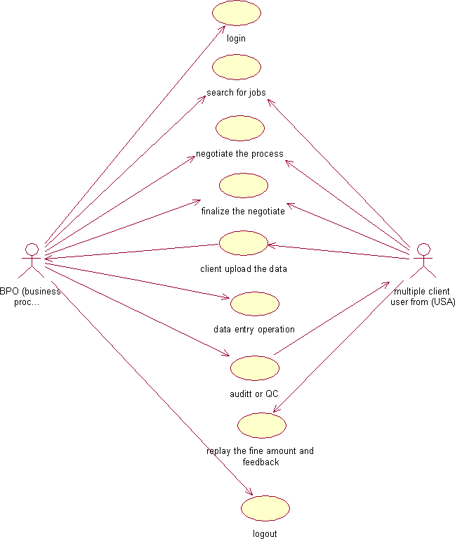

Fig.3. UML USE CASE DIAGRAM
- UML CLASS DIAGRAM:

The UML class diagram is to illustrate class interfaces and their actions. They are used for static object modeling, we have already introduced and used their UML diagram while domain modeling.

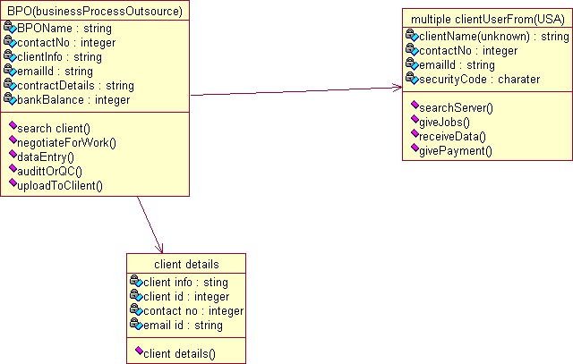

Fig.5. UML CLASS DIAGRAM

- UML SEQUENCE DIAGRAM:
A sequence diagram illustrates a kind of format in which each object interacts via message. It is generalize between two or more specialized diagram.
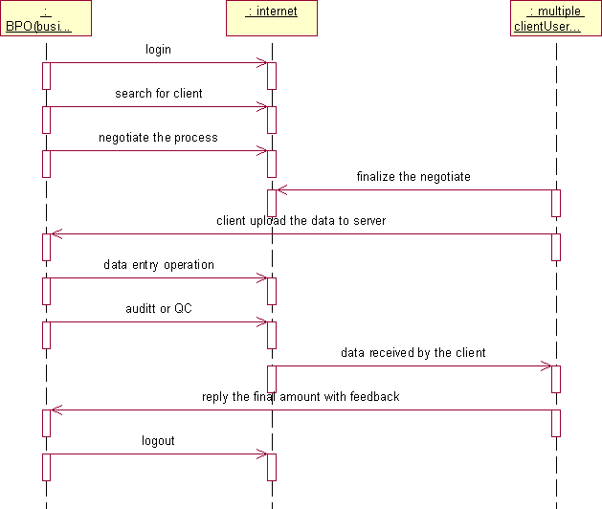

Fig. 5.1SEQEUENCE DIAGRAM
Communication diagram illustrate that object interact on a graph or network format in which object can be placed where on the diagram. In collaboration diagram the object can be placed in anywhere on the diagram. The collaboration comes from sequence diagram.

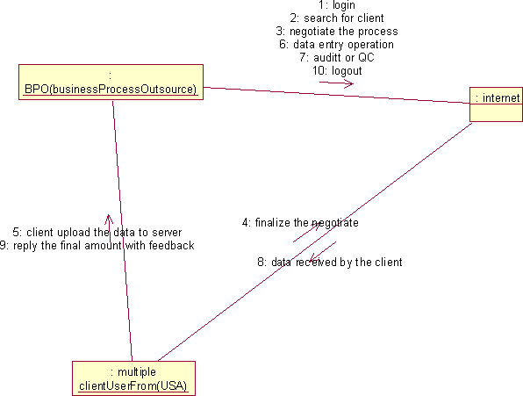

Fig.5.2COLLABRATION DIAGRAM

- PARTIAL LAYERD LOGICAL ARCHITECTURE DIAGRAM:
UI
Text
Swing
Recruitment Form
BPOS

Domain
Client
Admin
BPOS
Feedback
Upload
OCR
Download
Data Entry
QC
Technical Services
SOAP
Log4J
Persistence
DBFacade

DEPLOYMENT DIAGRAM AND COMPONENT DIAGRAM
Deployment diagrams are used to visualize the topology of the physical components of a system where the software components are deployed.
<<database>>
:SQL
<<client workstation>>: GenericPC
SQL
FTP
<<server>>

Fig.9.1.DEPLOYMENT DIAGRAM
Component Diagram
Component diagrams are used to visualize the organization and relationships among components in a system.

RESULT :
Thus the mini project for BPO management system has been successfully executed and codes are generated.

Ex.No:15 LIBRARY MANAGEMENT SYSTEM

AIM
To design an object oriented model for Library Management System using Rational Rose software and to implement it using Java.

PROBLEM STATEMENT
The library management system is a software system that issues books and magazines to registered students only. The student has to login after getting registered to the system. The borrower of the book can perform various functions such as searching for desired book, get the issued book and return the book.

CLASS DIAGRAM
A class diagram in the unified modeling language is a type of static structure diagram that describes the structure of a system by showing the system’s classes, their attributes, operations and the relationships among objects. The library management system makes use of the following classes user,
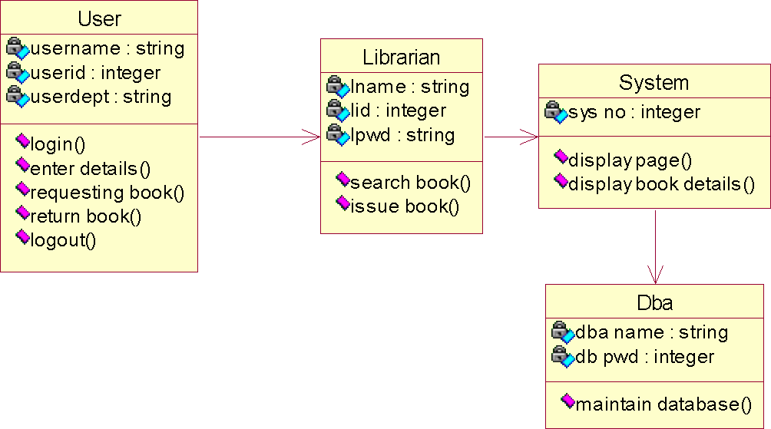

librarian, system and DBA.

USE CASE DIAGRAM
Use case is a list of actions or events. Steps typically defining the interactions between a role and a system to achieve a goal. The use case diagram consists of various functionality performed by actors like user, librarian, system and DBA.




login
enter name and password
<<actor>> projection of
display page
user
requesting for book
display book details
search for book
librarian
issue book
return book
maintain database
DBA

DEPLOYMENT DIAGRAM
Deployment diagram is a structure diagram which shows architecture of the system as deployment of software artifacts to deployment target. It is the graph of nodes connected by communication association. It is represented by three dimensional box. The device node is library management system and execution environment nodes are user, librarian, system and DBA.
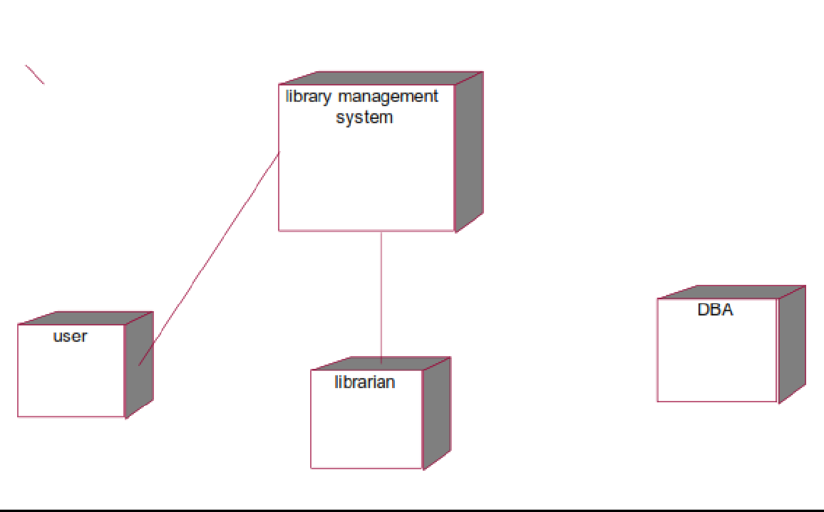

COMPONENT DIAGRAM
Component diagram shows the dependencies and interactions between software components. Component diagram carries the most important living actors of the system i.e, user, librarian and DBA.

library management system
user
librarian
DBA

STATECHART DIAGRAM
State chart diagram is also called as state machine diagram. The state chart diagram contains the states in the rectangular boxes and the states are indicated by the dot enclosed. The state chart diagram describes the behavior of the system. The state chart diagram involves eight stages such as login, enter details, requesting for book, display book details, search book, issue book, return book and logout.



login
enter details
requesting for book
display book details
logout
return book
issue book
search book

COLLABORATION DIAGRAM
Like sequence diagram collaboration diagrams are also called as interaction diagram. Collaboration diagram convey the same informations as sequence diagram but focus on the object roles instead of the times that messages are sent. Here the actions between various classes are represented by number format for the case of identification.

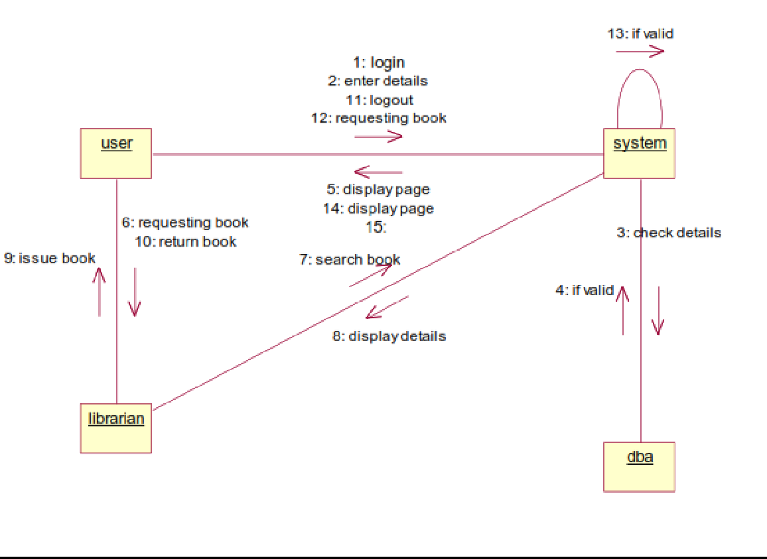

SEQUENCE DIAGRAM
A sequence diagram represent the sequence and interactions of a given use case or scenario. Sequence diagram capture most of the information about the system. It is also represent in order by which they occur and have the object in the system send message to one another. Here the sequence starts with interaction between user and the system followed by database. Once the book have been selected the next half of sequence starts between librarian and user followed by database.

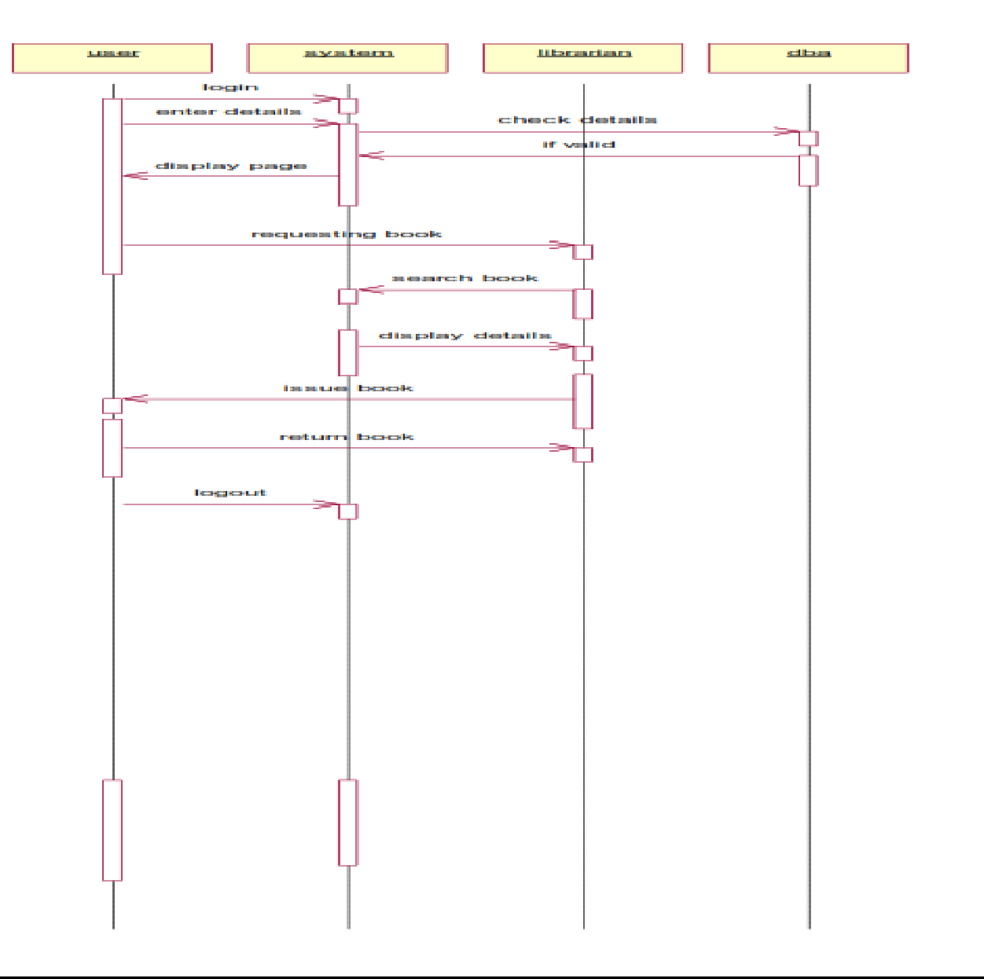

ACTIVITY DIAGRAM
Activity diagram are graphical representation of workflows of stepwise activities and actions with support for choice, iteration and concurrency. Here in the activity diagram the user login to the system and perform some main activity which is the main key element to the system.

RESULT
Thus the various UML diagrams for library management system was drawn and the code was generated successfully.

Ex.No:16 STUDENT INFORMATION SYSTEM

AIM
To design an object oriented model for Student information system using Rational Rose software.

PROBLEM STATEMENT

The student must register by entering the name and password to login the form. The admin select the particular student to view the details about that student and maintaining the student details. This process of student information system is described sequentially through following steps. The student registers the system. The admin login to the student information system. He/she search for the list of students. Then select the particular student. Then view the details of that student. After displaying the student details then logout.

CLASS DIAGRAM
The class diagram is the graphical representation of all classes used in the system. The class diagram is drawn as rectangular box with three components or compartments like class name, attributes and operations. The student information system makes use of the following classes like student, staff, system, DBA and server.

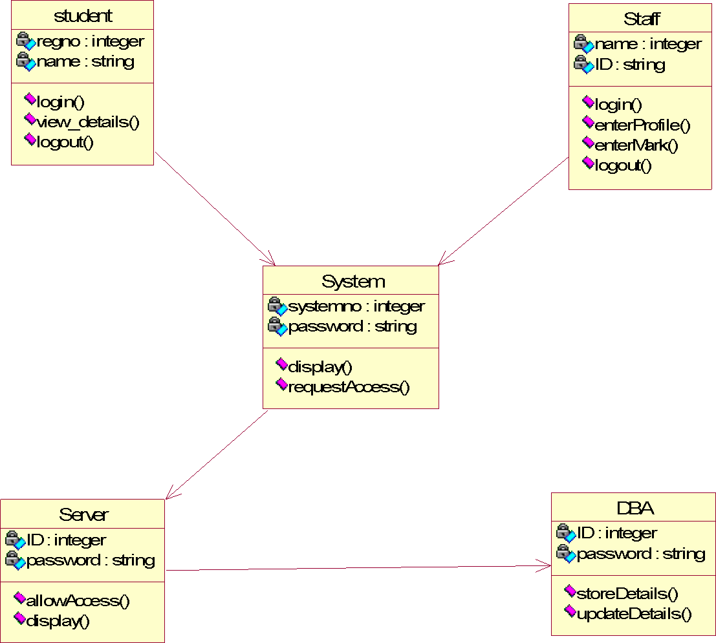

COLLABORATION DIAGRAM
A Collaboration diagram represents the collaboration in which is a set of objects related to achieve a desired outcome. In collaboration, the sequence is indicated by numbering the message several numbering schemes are available. Login, request access, allow access, display, view details, logout, login, request access, allow access, display, enter profile, enter mark, provide data, logout, store data, update data.

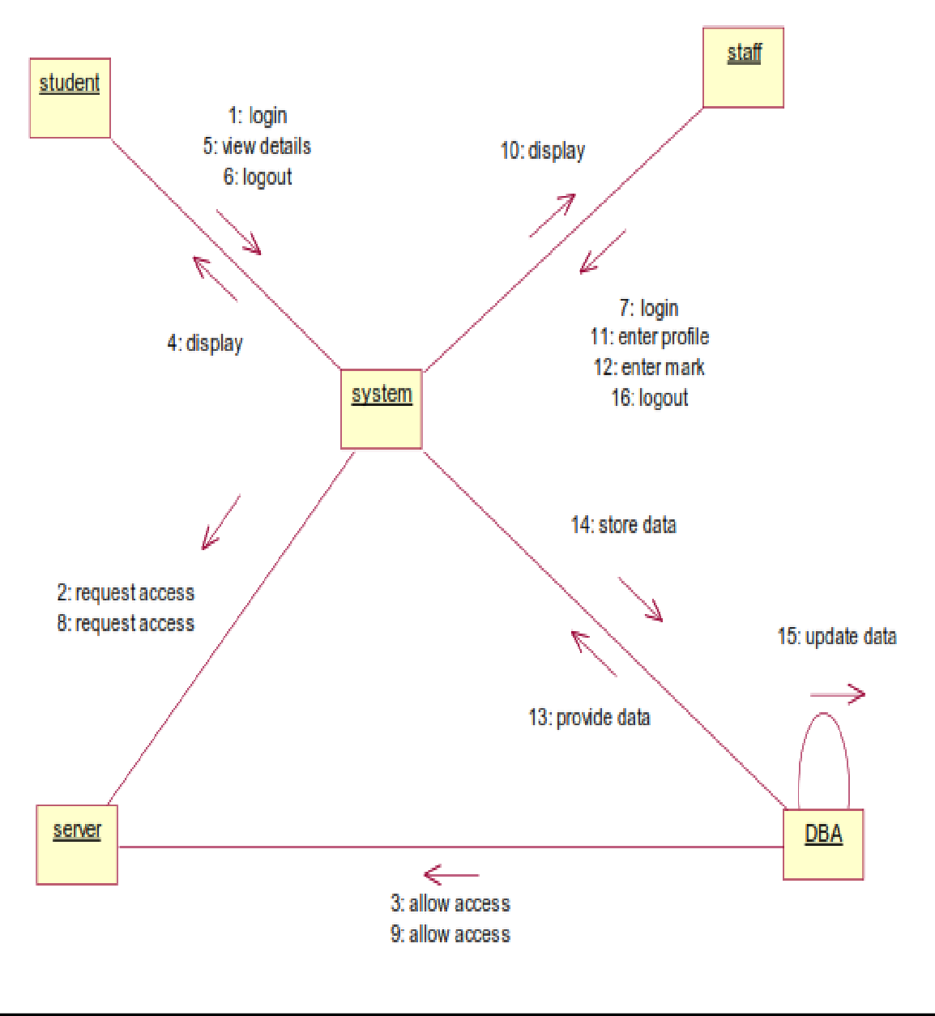

SEQUENCE DIAGRAM
A Sequence diagram represent the sequence and interaction of a given usecase or scenario. Sequence diagram capture most of the information about the system. Here the sequence starts between the student and the system. The second half of interaction takes place between staff and system then by police and followed

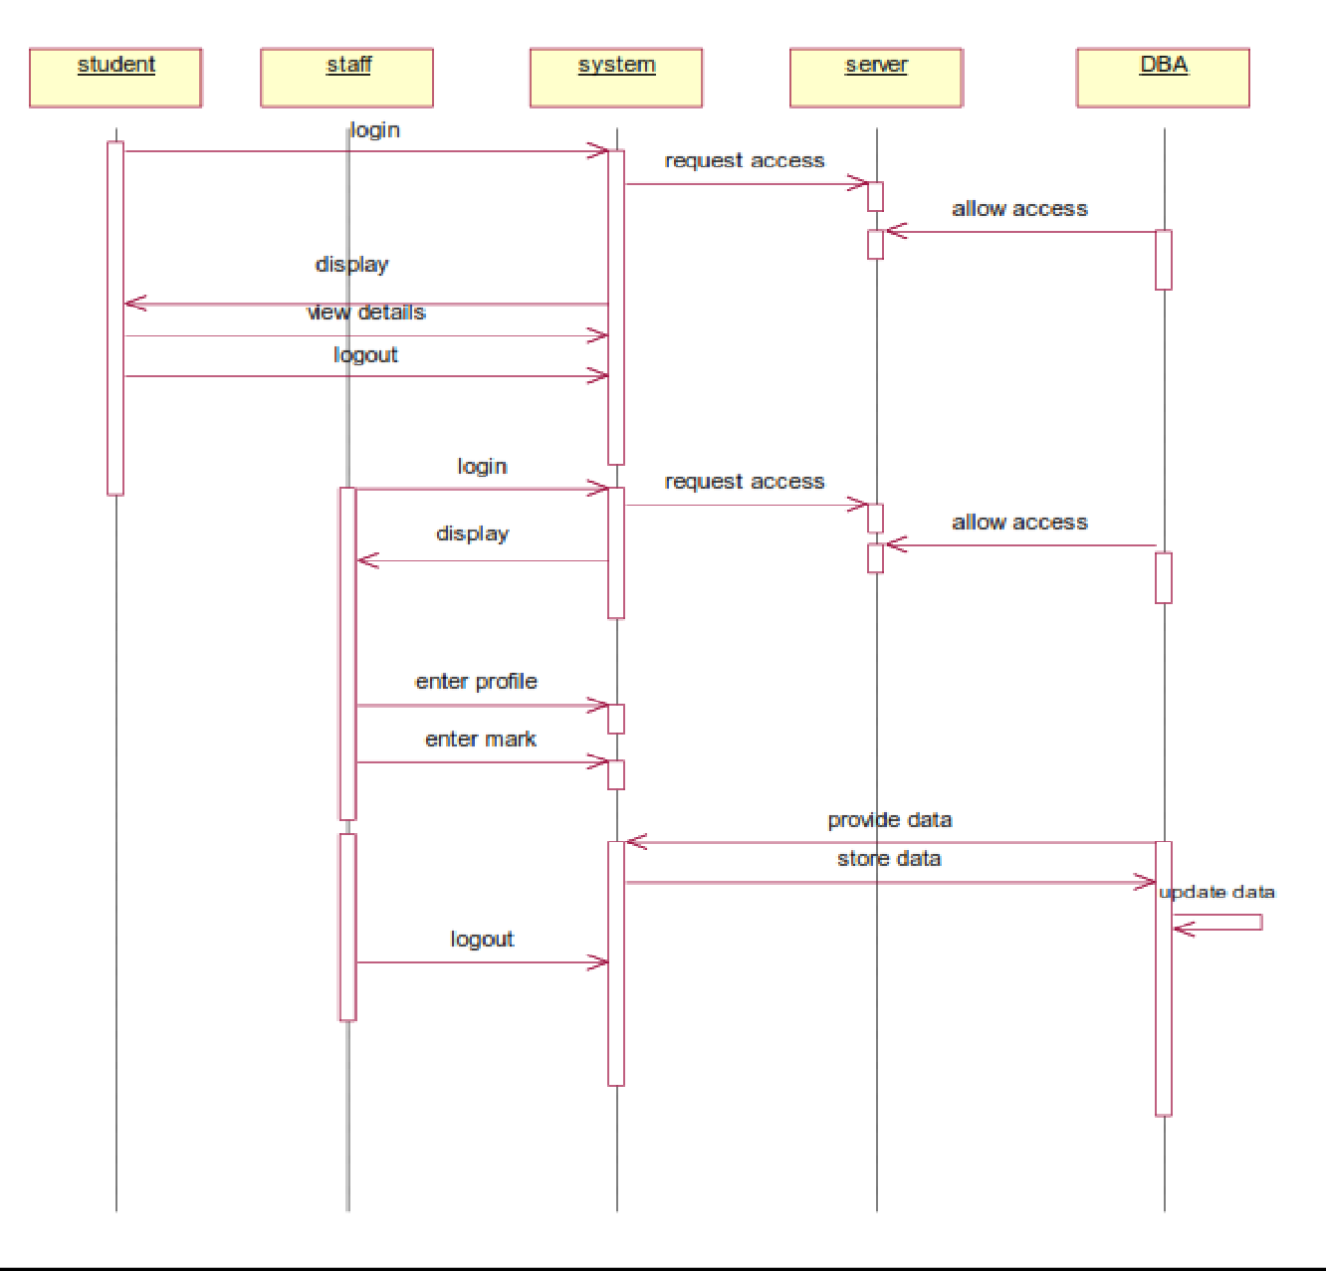
by database. The student first login to the system and then view the details of the details. Staff login to the system enter mark and enter the details of the student. DBA store and update the details of the student.

COMPONENT DIAGRAM
Component diagram carries the major living actors of the system. The component diagram main purpose is to show the

structural relationship between components of the system.The main component of the system is student information system and the other components of the system are student, staff and DBA.
DBA
student
staff
student information system

USE CASE DIAGRAM
Use case diagram is a graph of actors, a set of use cases, association between the actors and the use cases and generalization among the cases. Use case diagram is a list of actions or events. Use case diagram was drawn to represent the static design view of the system. Steps typically defined the interactions between a role and a system to achieve a goal. The use case diagram consists of various functionality performed by the actors like student, staff, system, DBA and server. The use case diagram consists of various functionality like login, display, enter profile, enter mark, view details, update details, allow access, request access, store details, logout.

login
display
<<actor>> projection of student information
enter profile
enter mark
s tudent
view details
staff
update details
allow acces s
server
DBA
reques t access
store data

DEPLOYMENT DIAGRAM
Deployment diagram shows the configuration of runtime processing elements and the software components processes and objects that live in them. Component diagram are used in conjunction with deployment diagram to show how physical modules code are distributed on various hardware platform. The processor node in the system is student information system and the execution environment nodes or device nodes are student, staff and DBA.

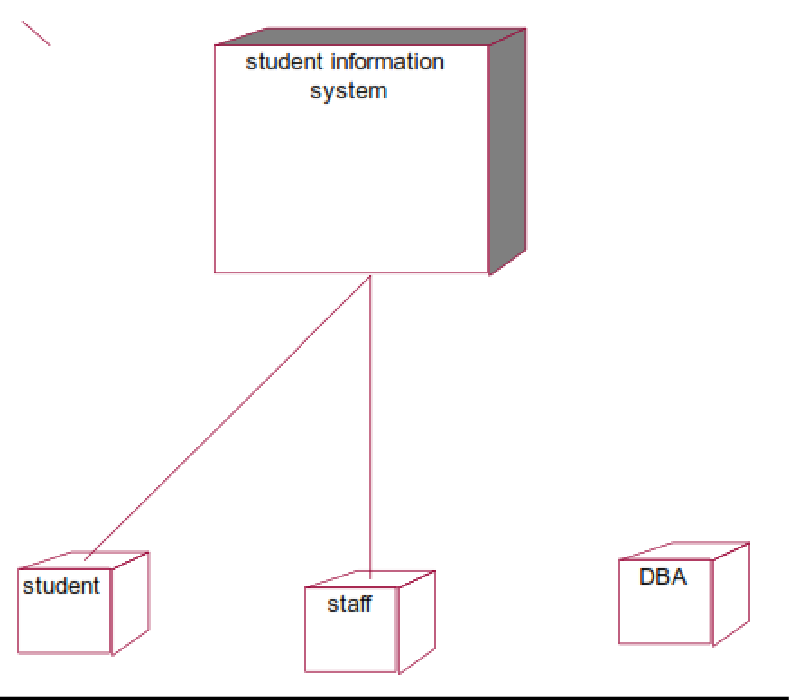

STATE CHART DIAGRAM
A State chart diagram is also called as state machine diagram. The state chart contains the states in the rectangular boxes and the states are indicated by the dot enclosed. The state chart diagram describes the behavior of the system. The state chart involves six stages such as login, enter mark, enter profile, view details, provide details, update details, store details and logout.


login
enter marks
enter profile
view details
logout
store details
update details

ACTIVITY DIAGRAM
Activity diagram are graphical representation of stepwise

activities and actions with support for choice, interaction and concurrency. Here in the activity diagram the student login to the system and view the details of the student. The staff login to the system for entering the student details and update the details in the database. The final interaction is the DBA store the details of the student.
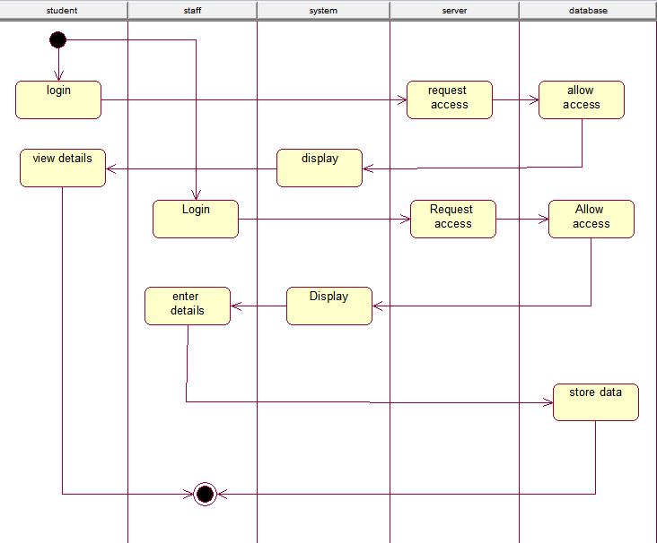

RESULT
Thus the various UML diagrams for student information system were drawn and code was generated successfully.

VIVA QUESTION
Ex.no 1: Passport automation system.
  - What is Object-Oriented Analysis and Design?
  - What is Class diagram?
  - What is Interaction diagram?
  - What is Sequence diagram?
  - What are the three ways and perspectives to Apply UML?
Ex.no 2: Book bank
- What is use case?
- What are Actors?
- What is Activity diagram?
- What is Component diagram?
- What is Deployment diagram?
Ex.no 3: Exam registration
- Explain about exam registration scenario?
- What is Inception?
- What is object?
- What is UML?
- What are the goals of UML?
Ex.no 4: Stock maintenance system.
- What is Collaboration diagram?
- What is State Chart diagram?
- What is a scenario?
- What tests can help find useful use cases?
- What are Three Kinds of Actors?
Ex.no 5: Online course reservation system
- What is Package diagram?
- Explain the include relationship.
- Explain the extend relationship.
- What is the generalization relationship?
- What is meant by POS system?
Ex.no 6: Airline/Railway reservation system
  - What do you mean by the term elaboration?
  - Enlist various tasks that are involved in elaboration.
  - What is domain model?
  - Why domain model is referred as visual dictionary?
  - How to create domain model?
Ex.no 7: Software personnel management system
- Define conceptual classes.
- What are description classes?
- What is association?
- What is attributes?
- Define aggregation and composition.
Ex.no 8: Credit card processing
- Differentiate single and multiple inheritances.
- Distinguish between method and message in object.
- When to create a subclass of superclass?
- How to create instance?

- Give a sample category list for identifying conceptual classes
Ex.no 9: e-book management system
- What is design pattern ?
- Write notes on pattern.
- When to use pattern ?
- What is GRASP ?
- Define the concept of creator ?
Ex.no 10: Recruitment system
- Explain about Recruitment system.
- Define Modular Design.
- What is Observer Pattern?
- List out the types of Coupling.
- List out the four main benefits in Design Pattern?
Ex.no 11: Foreign trading system
- Define Behavioral.
- Define Creational.
- What is meant by Low Coupling ?
- Define Structural Pattern.
- Define Factory Method.
Ex.no 12: Conference management system
- What is Information Expert?
- Define Singleton Pattern.
- What do you mean by High Cohesion?
- Define Modular Design
- Mention Interface and Domain Layer responsibilities
Ex.no 13: BPO management system
- List the relationships used in class diagram.
- What is use of system sequence diagram?
- What do you mean by sequence number in UML? Where and for what it is used ?
- Define package and draw the UML notation for package?
- Differentiate sequence and communication diagram.
Ex.no 14: Library management system
- Explain about Library management system.
- Define component with example.
- Define System Events and the System Boundary.
- What is meant by Inter-System SSDs?
- What is meant by link?
Ex.no 15: Student information system
- What are steps for mapping design to coding?
- What are the issues in OO Testing?
- List the four level of OO testing.
- Define GUI Testing
- What is regression testing?

